

ENTERPRISE WEB SOFTWARE DEVELOPMENT

**COMP1640**



**TEAM PRIME**

**GIT-HUB REPOSITORY:**

<https://github.com/TruongDuongHongPhuoc/COMP-1640.git>

**GOOGLE DRIVE REPOSITORY:**

[https://drive.google.com/drive/folder](https://drive.google.com/drive/folders/0B40vjbUs9BsoYTFpWF9MandLNkU) [s/0B40vjbUs9BsoYTFpWF9MandLNkU](https://drive.google.com/drive/folders/0B40vjbUs9BsoYTFpWF9MandLNkU)

**GROUP MEMBERS:**

LE NGUYEN NHUT KHOI - SCRUM MASTER / PROGRAMMER, TESTER, DATABASE DESIGNER

TRUONG DUONG HONG PHUOC / PROGRAMMER, TESTER, WEB DESIGNER

NGUYEN PHUOC LOC – PROGRAMMER / TESTER / INFORMATION ARCHITECT

Table of Contents

I. Database 3

1 Security 3

2 Appropriate Data Types 4

3 Role Implementation 5

4 Referential Integrity. 5

5 Validation 6

6 Design Documentation 6

II. Site Design 8

1 Usability Heuristics (Nielsen’s Heuristics) 8

Flexibility and efficiency of use 11

Aesthetic and Minimalist Design 12

Help users recognise, diagnose, and recover from errors 13

Help and documentation 13

2 Usability 14

3 Accessibility 14

a) Color for blind people 14

b) Color Factors 15

c) Color scheme for colour-blind people 15

4 House Style Consistency 16

a) Maintainability 16

b) Reusability 16

5 Responsive Design 16

6 Other technologies utilised 18

7 Other aspects considered 19

8 Optimize image 19

9 Minify CSS, JavaScript, and HTML 19

10 Keeping it basic 20

11 Information Architecture 20

a) Web Design 21

III. Functionality 28

1 Security 28

a) Hash code for password 28

b) Role checking 28

c) JSON Web Token 28

2 Login and Register 28

3 Submission of Contributions 30

4 Update Contribution 30

5 Delete Contribution: 31

6 Feedback Contribution 31

7 Reset password and Forgot password: 32

8 View contribution and public contribution / Filter by Faculty and Academic Year 33

9 First Login Animation 34

10 Approve and Public contribution 35

11 Statistics and Exception Reports 35

a) Guest: 35

b) Marketing Manager: 36

c) Exception reports: 38

12 UML diagrams 39

a) Use case 39

b) Class Diagram 40

13 Website Analytics 40

a) Summary and Trends 41

b) Device Category, Countries, Operating System and Browser 42

c) Top Traffic Sources, Events and Landing Pages 44

d) Top Pages 46

14 Further Developments 48

15 Code Snippets 48

IV. Testing 62

1 Test plan 62

2 Scope 75

a) Test Log 75

3 Sufficient Data to Fully Test 77

V. Agile Methods Followed 78

1 GitHub 78

2 Development tools and workflow 78

3 Sprints 78

4 Burndown Charts 78

5 Minutes of Meetings 82

6 User Stories 84

VI. Screencast and Presentation 86

1.1 Presentation: 86

1.2 Screencast 86

2 Conclusion 86

References 87

# Database

MongoDB is an open-source document database with high performance, availability, and automatic scaling. A record in MongoDB is a document, which is a data structure composed of field and value pairs

MongoDB is a document database with the scalability and flexibility you want with the necessary querying and indexing.

[A review of various aspects of MongoDB databases](https://www.academia.edu/download/60661268/a-review-on-various-aspects-of-mongodb-databases-IJERTV8IS05003120190921-10051-a8lu8n.pdf)

In this project database, six tables are implemented. In detail, the “Account” table is used to store all user account data for all five roles, and it also has password hashing. As there are five roles, Admin, Manager, Coordinator, Student and Guest, there is a “Role” table to store these roles as mentioned above. For users to add multiple contributions, there is a “Contribution” table to store all the information when adding donations. However, files are not stored directly in the database. A file path is stored whenever a user adds a new contribution, and the file server is responsible for storing the physical file according to the file path. For users to give feedback and chat with each other, there is a “Feedback” table to store the created feedback. There is more than two faculty and academic year information, so the two tables, “Faculty” and “Academic Year”, can store that information in the database. In the next section, security and referential integrity are discussed.

## Security

Security within the database was of high importance. The “Account” table is responsible for storing details concerning members like admin, manager, and coordinator, as well as students and guests. As such, appropriate measures have been taken to ensure the integrity and confidentiality of this sensitive information. MongoDB provides various security features to secure your deployments, such as authentication, access control, and encryption, to secure your MongoDB deployments. MongoDB supports three fundamental security mechanisms. First is “Role-Based Access Control”; this mechanism allows administrators to grant and restrict user collection-level permissions, preventing accidental data and access disclosure. The second is “Encryption at Rest”; this mechanism encrypts database files on disk, preventing unauthorised access to your data by individuals who lack database credentials but have access to the computer hosting your database. The last one is “Transport Encryption”, now known as TLS/SSL in short type; this mechanism encrypts your data over the network, protecting it as it travels over an insecure network. However, it cannot protect your data from a privileged user or when it sits on disk. MongoDB Atlas, the fully managed service for MongoDB deployments in the cloud, provides additional security features such as authentication and authorisation, encryption, IP access list, and cloud provider support.

In MongoDB, only user accounts allowed or invited by the database's creator can be accessed. Moreover, the creator can set permissions according to their requirements and the need to use the database. Additionally, to improve the database security feature, the application will only store encrypted passwords; no plain text passwords will be allowed in the database. The application will encrypt the password by BCrypt Hashing and store it in the database for later use when comparing the encrypted password when logging in. BCrypt Hashing is very safe because it is a one-way encryption, which means the encrypted password can not be or is very hard to decrypt by some popular decryption tools today. Moreover, the same password is encrypted to different encryption strings each time the encrypting process is done. This means that even if the user accounts are leaked out, or in the event of a security breach, the attacker can not read or know any of these password data.

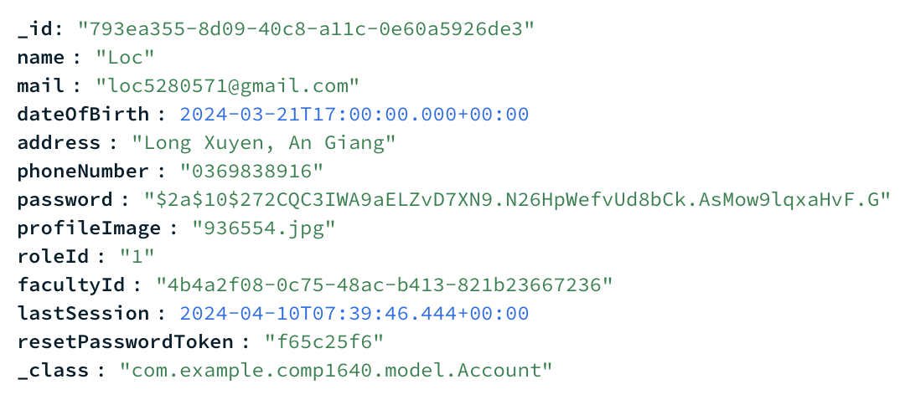

Figure . BCryte Hash Password

<https://www.mongodb.com/docs/manual/security/?_ga=2.64378022.809424892.1710680535-529619845.1709182177>

## Appropriate Data Types

In database design and implementation, a diverse array of data types guarantees that every column can adeptly store pertinent information, aligning with client specifications and facilitating support for the front-end application. Attracting the MVP (minimum viable product) absent appropriate data types could prove challenging or unattainable in certain instances.

Warning: This database timestamp is below; we currently do not have it, but we will add it to our web in the future ( next week's presentation ), so we faded this paragraph below.

A vital example of this, and a requirement, was to ensure the user’s last log-in time and date will be displayed upon their next log-in. A TIMESTAMP datatype was the most appropriate datatype to use in this case as it shows the relevant information in a concise format as well as the most suitable way to store this information generated by the application, ensuring all data in this column is kept in a consistent format. A VARCHAR datatype could also have been used here - it would store the same information. However, in the interest of data analysis, this would be extremely difficult to manipulate with SQL commands, whereas the TIMESTAMP can be manipulated with DDL statements.



Figure section last login

## Role Implementation

To enact the roles outlined by clients and user stories, every user in the database is assigned two values: RoleID and FacultyID. The RoleID dictates the tasks a user can undertake within the AMS (Academic Management System). For instance, access to specific application areas is restricted based on RoleID; for example, RoleID = 1 corresponds to the Admin role, granting access solely to administrative pages and associated tasks. Conversely, RoleID = 4 designates a student role, enabling users to upload contributions. FacultyID serves to identify the faculty affiliation of staff members or students. This allows staff members to review, comment on, and approve magazine articles submitted by students within their faculty. Likewise, guest accounts associated with a specific faculty are limited to viewing contributions aligned with their corresponding FacultyID. For example, the guest account for the Law faculty, with FacultyID = 5, exclusively accesses contributions submitted by Law students.

## Referential Integrity.

Referential integrity is rigorously maintained within the design of the magazine management system through the implementation of appropriate constraints. This is pivotal for supporting the application's functionality and adhering to the specified requirements of the overall product. Illustrated in the Entity-Relationship Diagram (ERD), the database comprises seven tables, each utilising a primary key to uniquely identify rows, while foreign keys establish logical connections between tables. This ensures that only 'good' data is accepted, minimising the risk of 'bad' values being entered; consequently, all INSERT statements must comply with these constraints.

Moreover, using foreign keys facilitates the implementation of additional functionalities, such as multiple image uploads. Each contribution (i.e., magazine upload) possesses its unique primary key, and its details, including title, file path, and the uploading user, are stored in the "contribution" table. To prevent duplicate clashes, the primary key column in this table is set to auto increment. A second table, named "images," is linked to the "contributions" table via a foreign key that references the primary key of the contribution table. This arrangement allows multiple images to be associated with a single contribution. Similarly, the database accommodates multiple comments being assigned to a magazine contribution.

## Validation

Users utilise a unique email address as their identifier to facilitate user login and access to the application. This email address is a distinct identifier for individuals, ensuring no two users can share the same email address. A UNIQUE key is applied to the email column to enforce this uniqueness constraint within the database. This measure reinforces the database's capability to accept only 'good' data, guaranteeing that each email address exists only once within the table.

## Design Documentation

An Entity-Relationship Diagram (ERD), depicted in Figure 2, was devised for the magazine management system's database to ensure the implementation of all necessary features. This ERD is the backbone supporting the frontend application in achieving the required functionality, particularly in role implementation and facilitating multiple images for a contribution. Six tables have been implemented, each equipped with appropriate constraints, enabling the establishment of relationships between them.

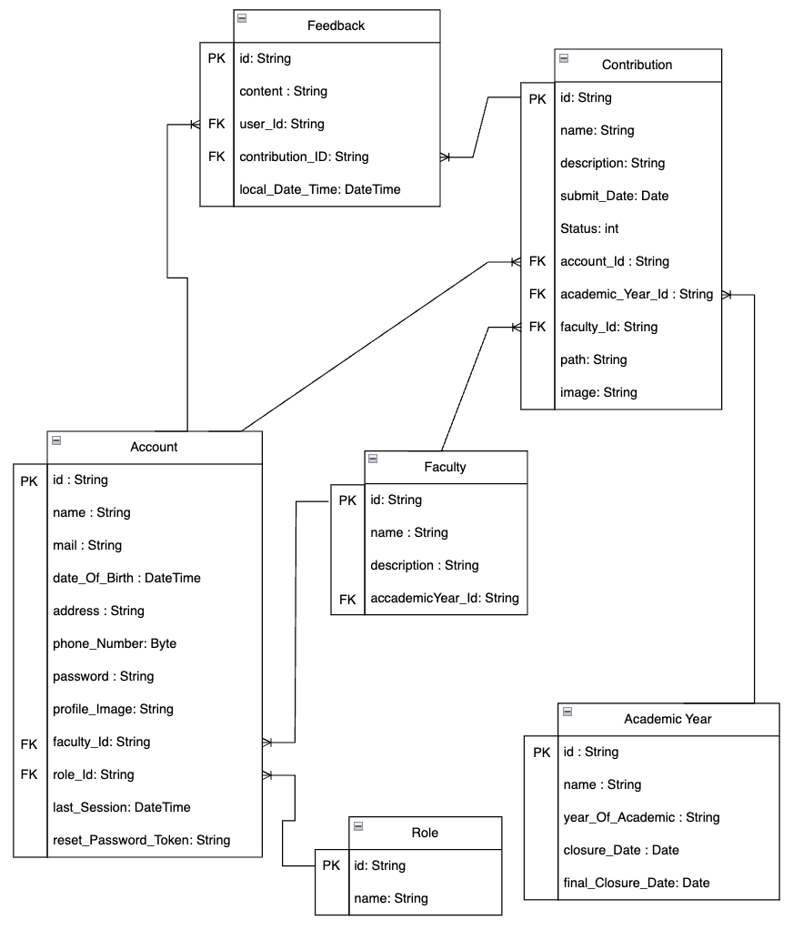

Figure ERD diagram

# Site Design

Site design is a pivotal aspect of any project, as it profoundly influences user experience. Our team meticulously strategies various design elements throughout development to ensure a user-friendly interface catering to diverse end-users. We aim to empower users to navigate and utilise the system effortlessly, even without prior access to instructional documentation.

We prioritise crafting a visually appealing GUI that seamlessly integrates aesthetics with functionality to achieve this. This involves meticulously selecting themes, colours, and design elements, adhering to modern web standards such as HTML5 and CSS. Additionally, we leverage popular frameworks like Bootstrap to streamline development and enhance the overall user experience.

By prioritising synchronised aesthetics and intuitive design principles, we aim to deliver a website that meets and exceeds user expectations, ultimately enhancing user engagement and satisfaction.

## Usability Heuristics (Nielsen’s Heuristics)

To ensure the system meets the requirements criteria of designing a friendly-to-use interface, we followed the Heuristics for user interface provided by Jakob Nielsen, who holds a PhD in human-computer interaction according to (Nielsen, April 24, 1994).

**Nielsen’s heuristics:** Visibility of system status**:**

According to (Nielsen, April 24, 1994) the first heuristic is the visibility of system status. In other words, it means the design should always notify the end-user information about what the system does in an amount of time, ideally immediately.

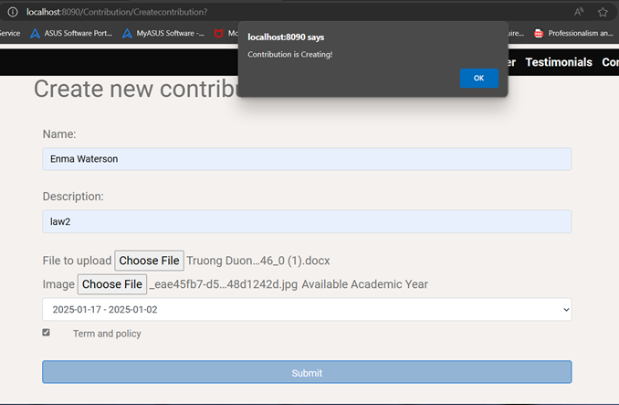

Figure heuristic 1

Match between the system and the natural world

According to (Nielsen, April 24, 1994) the second heuristic is that the design should match the real world. In other words, the system should provide a simple definition and terminology. The icon must be transparent to users and be easy to identify. For example, following this heuristic, we use the word login rather than authenticate for the authentication feature.

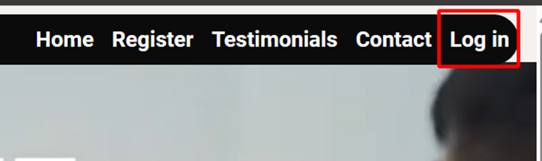

Figure Match between the system and the natural world

User control and freedom

According to (Nielsen, April 24, 1994) the third heuristic is user control and freedom, which means users have the freedom to control. They might need an emergency exit door to prevent unwanted actions. Often, this feature exists as an undo and redo function.

Following this heuristic, we designed an exit way for users as a logo in the page's header. Whenever they accidentally access an unwanted page, they can leave and return to the homepage quickly; we also create an update function for each system creation. For example, for contributions, users can update as many as they want after creation.

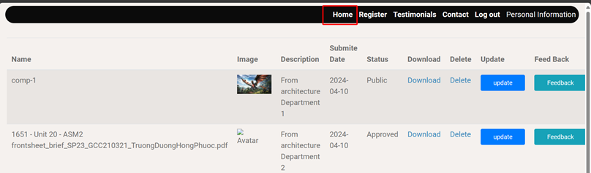

Figure user control and freedom

Consistency and standards

According to (Nielsen, April 24, 1994) the fourth heuristic is consistency and standards, meaning design must make users confident that their understanding is correct. Users should not wonder about different words. Situations or actions mean the same things. The design should be both internal and external.

Following this heuristic, we design the user with simple words to describe a function, for example.

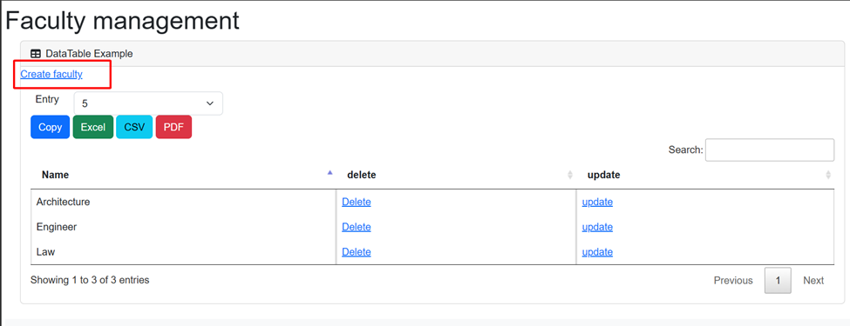

Figure consistency and standards

Error prevention

According to (Nielsen, April 24, 1994) the fifth heuristic is error prevention, which means the design must have an error page. Whenever an error occurs, the page will be called. The system should deliver an error message to users to ensure they know what is happening. For example, a system should design confirmation options before committing an action.

Following this heuristic, we force the end-user to follow constraints before committing an action. For example, we force the unauthorised user to register an account. When registering an account, they must follow our rule of creating a valid password to prevent the account from being attacked and ensure the user protects their account correctly.

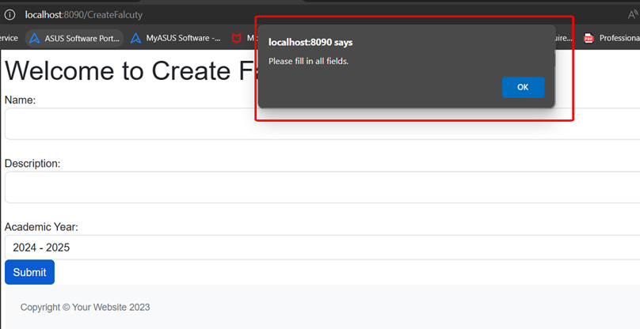

Figure error prevention

Recognition rather than recall

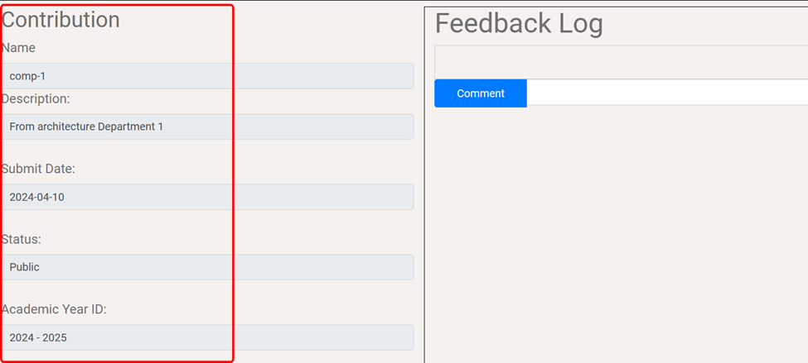

Figure Recognition rather than recall

According to (Nielsen, April 24, 1994) the sixth heuristic is to design a convenience for the end-user, for example, to minimise user memory on how to use the system. Make the option visible without requiring any information to be remembered from one part of the interface to another.

Following the heuristic, we always show the ID or name of the information the user wishes to update. For example, we show the ID of the contribution for the end-user to make sure they know which one they are updating. Furthermore, the contribution ID will show when giving feedback to ensure users know which one they are commenting on.

### Flexibility and efficiency of use

According to (Nielsen, April 24, 1994) the seventh heuristic is design flexibility and efficiency of use. In other words, this means allowing shortcuts for expert users while catering to inexperienced and experienced users for efficient interaction. In addition, the system could provide accelerators, personalisation or customisation to accommodate different types of users.

Following this heuristic design, we create a customisable profile picture for users. For example, some people might want simple profile pictures, but some users might wish for more personal, customised profiles.

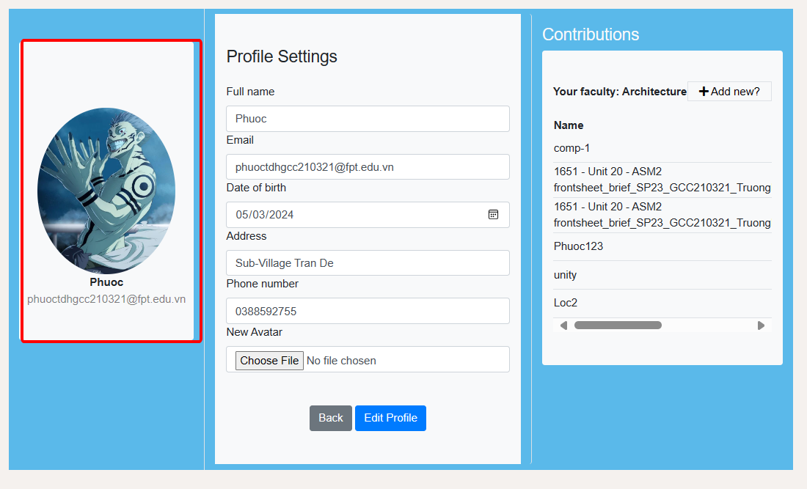

Figure design flexibility and efficiency

### Aesthetic and minimalist design

According to (Nielsen, April 24, 1994) the eighth heuristic is a minimalist design, which means it must be designed in the minimal way possible and meet the project's requirements. For example, there is no need to create a library since no requirement is needed, and it is not a crucial need for any of the end-users.

Following the heuristic, our website is designed minimally so that end-users can quickly understand what they are participating in without minding nonsense functions. We also sure make the website look good and easy to use at the same time.

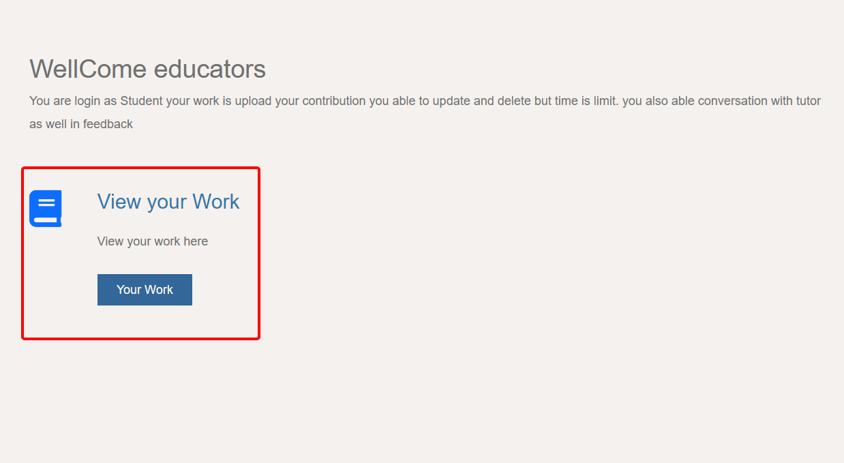

Figure minimalist design

The user logs in as a student, and the feature that the student is accessible only will appear.

### Help users recognise, diagnose, and recover from errors.

According to (Nielsen, April 24, 1994) the nine heuristics help end-users recover from errors. It is essential to prevent any potential error. Still, sometimes, errors might happen due to problems with using different types of devices, browsers, etc. When an error occurs, it is crucial to help users solve it. For example, the error page usually provides an email or other contact method to help the user.

By following the heuristic of our website, when an error happens, we provide an email contact and a phone number for the user if they need to solve it quickly.

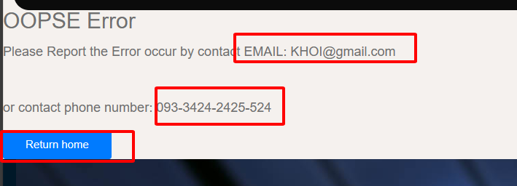

Figure recover from errors

### Help and documentation

According to (Nielsen, April 24, 1994) the last heuristic for designing a user interface is help and document. This helps document a diminutive text that guides inexperienced users to make it easier to use the system without reading any guide document.

Following this, we have small text above the text field where users input text to create or update other things.

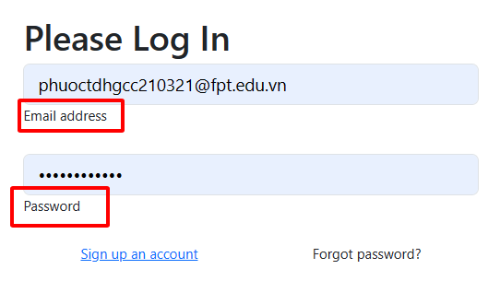

Figure help and document

## Usability

Usability is the most excellent way to expand customers from different devices; each person has a choice and prefers devices such as desktops, mobile phones, or tablets. To make the website more useable and flexible on different devices, bootstrap is a great technology to implement without changing the website's back-end, and it works reasonably well. For example, we have tested the homepage of our website. The edge developer tool is used to simulate devices on our website.

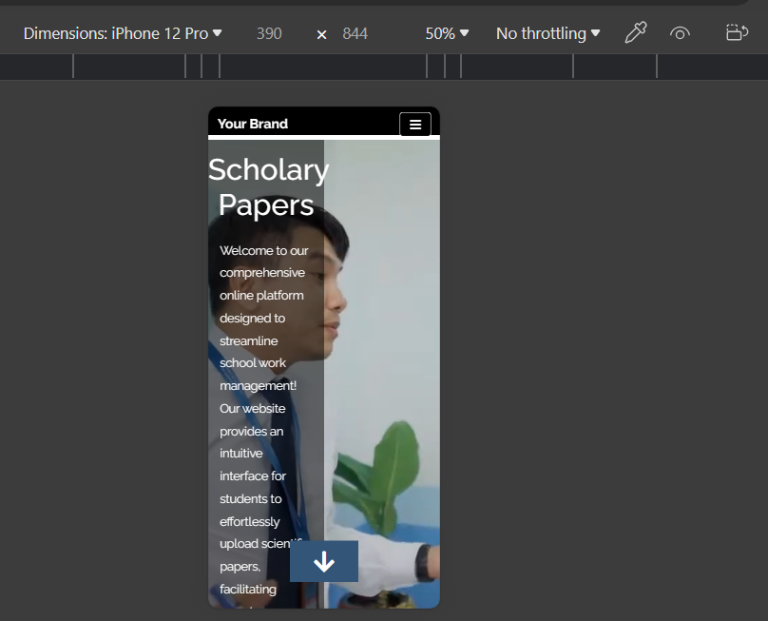

Figure interace in phone

## Accessibility

We made sure there was a big difference between colours so everything was clear to see; we ensured you could do things fast and without any problems. By thinking about these things, we made the MMS website easy and helpful for everyone who uses it.

### Color for blind people

Some people suffer from colour blindness. To prevent this from our website, we have chosen a colour theme that blind colour people wouldn’t be so distracted and uncomfortable while using our website due to the theme. We decided that black and white are the primary colours; white is the focus while developing the user interface, which makes our website accessible to many kinds of audiences.

### Color Factors

Regarding the factors of colour, we research colour psychology and how it will affect people in deciding which colour suits our user interface. We determined that the colour theme would be white. By contrast, we will use black to make white more focused. According to (alvi, 2017) colours can affect human feelings differently depending on other colours. Research conducted in 2020 with 4,589 people taking part tells that 43% of people see white as a relief emotion; in the same paper, the author said that white could give people a feeling of freshness and cleanness.

After considering various colours, we decided to use white and black, white as the primary colour due to the feeling it gave to people that it was clean, fresh and relieving. In addition, the colour of white is also considered a modern colour due to the comfort of it.

### Color scheme for colour-blind people

According to (Woods, n.d.) there could be many kinds of colour blindness. Still, they are commonly categorised into four types of colour blindness: red-green, blue-yellow, monochromacy, and tetrachromacy.

According to (Meng and Tanaka, 2019) red and green colour-blind people have difficulty identifying the red and green colours. Our website is suited for this colour-blinde to lacking colour. Predominantly red and green.

According to (McCann and McCann, 2019) Tritanopia or blindness is blue-yellow, and the person who has tritanopia has symptoms of blue appearing in green and yellow and orange appearing in pink. Based on our website's colour theme, people with tritanopia can still use our website generally due to our lack of blue and yellow colours. The blue colour only appears in the button so it would be more focused while using our website and so less of blue colour.

The last two other colour blinds are rare; monochromacy people cannot see colour at all but the deep of the light. For example, they might see yellow objects as lighter and Purple objects as much darker. It wouldn’t be difficult on our website because we only use black and white and a little colour to polish the website. Still, it wouldn’t be comfortable. Like tetrachromacy, we didn’t use much colour, so it would be distracting for people with tetrachromacy, making people see colours that the average person cannot see.

## House Style Consistency

We use HTML5 and Bootrap to design most of the user interface; besides considering designing the website, we also focus on Style Consistency. Using the same framework makes the website Consistent And easier to change in the future. We can easily maintain and reuse the existing template if stakeholders require it.

### Maintainability

For maintainability, we separate the header and footer from the body. For example, we cut out the header and footer, put them on the same page, and then use them on many different pages, which means when the system needs to upgrade or exchange something, we need to change one file, and then another will be changed too. For example, when the user didn’t like the header, we could easily change the header file. It gives crucial ease in maintaining our web view.

### Reusability

Our website is optimised for mobile display, ensuring usability and accessibility on smartphones. This adaptability expands our reach and allows users to engage seamlessly with our content and features, regardless of their device. By prioritising mobile optimisation, we're future-proofing our platform and reinforcing our commitment to delivering a user-centric experience

## Responsive Design

Our website is designed to be responsive and adjusts flawlessly to various screen sizes, including smartphones. This adaptability ensures that users can easily access and interact with our content and features regardless of their device.

**Bootstrap:**

* According to (getbootstrap, n.d.) Bootstrap is an open-source framework for front-end web development. The Bootstrap framework provides a collection of HTML, CSS, and JavaScript. It is easy to modify the shape, grid, font text, and colour; it is easy to use for all foundations. It also provides perfect work for all browsers and devices, whether phone, desktop, or tablet work well.
* Initially, Bootstrap banned Twitter Blueprint, which Mark Otto and Jacob Thornton developed as Twitter's internal framework. After a long time of development, Twitter contributed to the project as part of the hack week. After that, it changed its name to Twitter Bootstrap and became a source on 8/19/2011.
* In the context of our website, Bootstrap and CSS were the main points of design. All of the GUI always have Bootstrap. It also has significant advantages cause Bootstrap supports developing font ends on many different devices without changing much in coding. It is beneficial because it does not require much change in code and remains good-looking in a changed view.

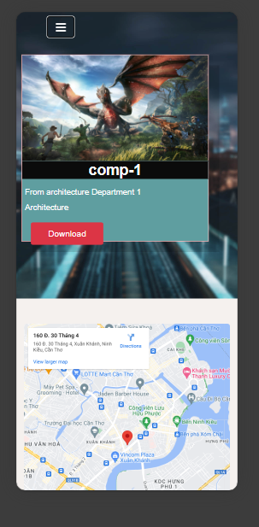

Figure reponsive design for phone

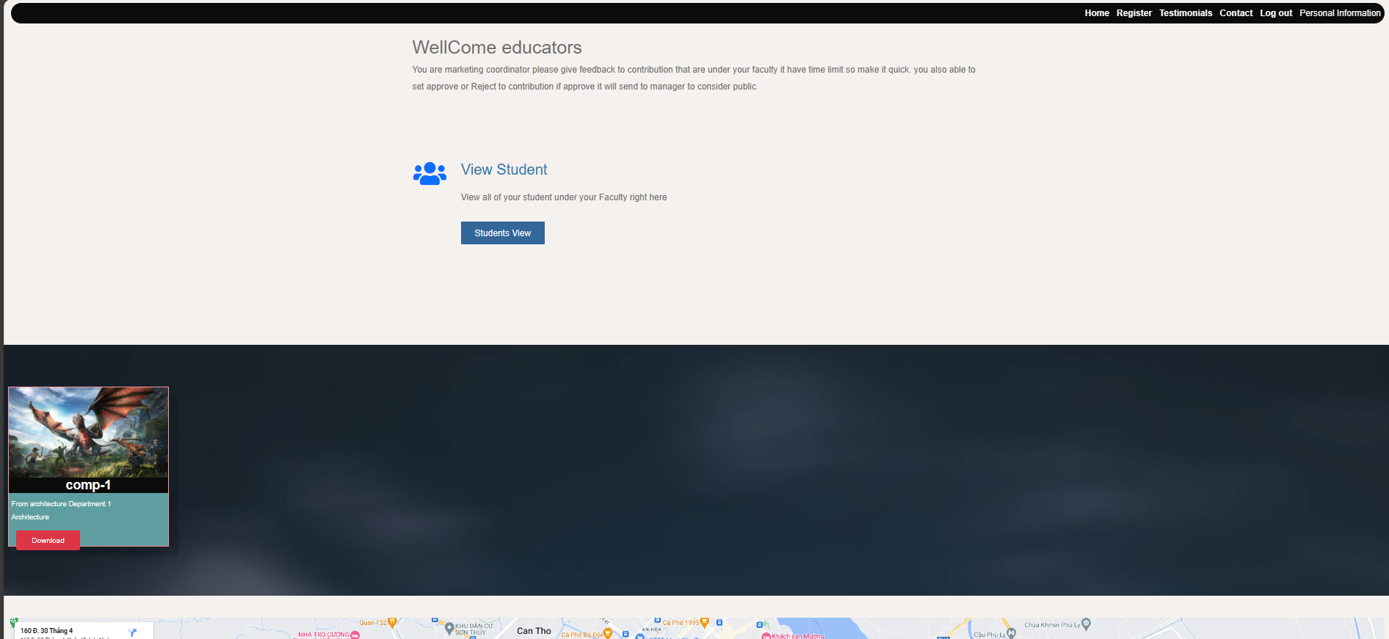

Figure reponsive design for desktop

## Other technologies utilised

*Some other technologies applied to build the front-end for the project: JavaScript, Thymeleaf and FontAwesome:*

JavaScript helps make our site interactive. It checks what users type into forms to ensure they are correct before sending them to the server. It also makes dropdown menus work smoothly without reloading the whole page.

Thymeleaf helps us communicate between the front and back ends of our site. It sends data back and forth, which is helpful for things like processing user logins and handling forms.

FontAwesome is like an extensive library of icons that we can use to make our site more visually appealing. We use it for things like buttons and navigation menus.

* **Use of JavaScript:**
* **Use of Thymeleaf:**

The header of a website serves as a consistent navigational element that appears at the top of every page, offering users essential information and tools to interact with the site.

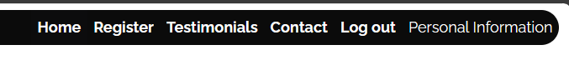

Figure use of thymeleaef header

* **Use of Font Awesome:**

We use Font Awesome to create icons. For example, the people icon stands for accounts. Vali Icon for contributions or works and some text

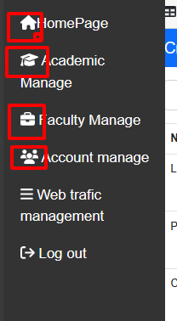

Figure use of font awesome icons

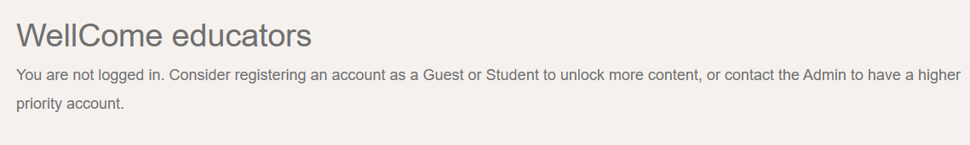

Figure use of fornt awesome text

## Other aspects considered

While considering designing the font end for the homepage, loading performance has a crucial role in the success of the project. The website might need to load several images and data, so I have devised an idea to increase the page speed for the project.

## Optimize image

In our project, the client requires a Google look and also good performance at the same time; optimise image will solve the problem of performance and Google look at the same time by reducing the size of the image file without changing much in the quality of the image, Tiny png is ideal for the required

## Minify CSS, JavaScript, and HTML

In our project, CSS, Javascript and HTML are significant responsibilities for the user interface. It could be a huge challenge if we needed to modify it. This could lead to many errors and a broken user interface. We remove unnecessary characters and delete things that do not participate in the user interface.

## Keeping it basic

All the sites keep minimum requirements and essential things during the website's design. We use white as the main colour and do not use any bright colours. For the text, we use the default HTML5 text. During the creation or upgrade of components, we only give the end-user reasonable fields and only show the crucial information if needed to prevent the user from the information. Furthermore, the navigation bar of our website is simply Tex, making it easy to understand and allowing users to navigate the pages they want to use.

## Information Architecture

A good information architecture helps the websites stay friendly for inexperienced users and easier to maintain in the future. They allow the website to keep organised and reasonable. Our website architecture focuses on a friendly user interface and makes the user's workflow as simple as possible, not requiring any remembering to use it properly. The information architecture is one of the crucial keys to a successful website. In our design information architecture, the view page will include a delete function, and the create and update function will send the user to another view. After the job, the system will send the user to the main view to see if the component is updated or appropriately created, which helps users save time in performing their work.

in the Figure of ….

Personal information stands for a view of the website. For example, Personal information is a view of Personal information. The Coordinator stands for Roles that are accessible from the view. For example, Personal information can be accessed by the Coordinator. From A, Arrow B stands for from the View A user able to access View B.

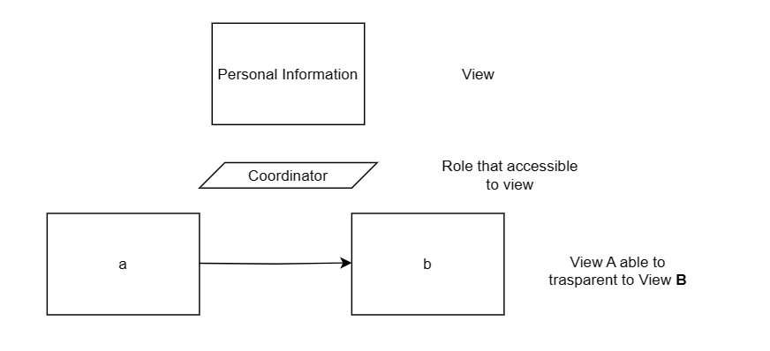

Figure key for the site design

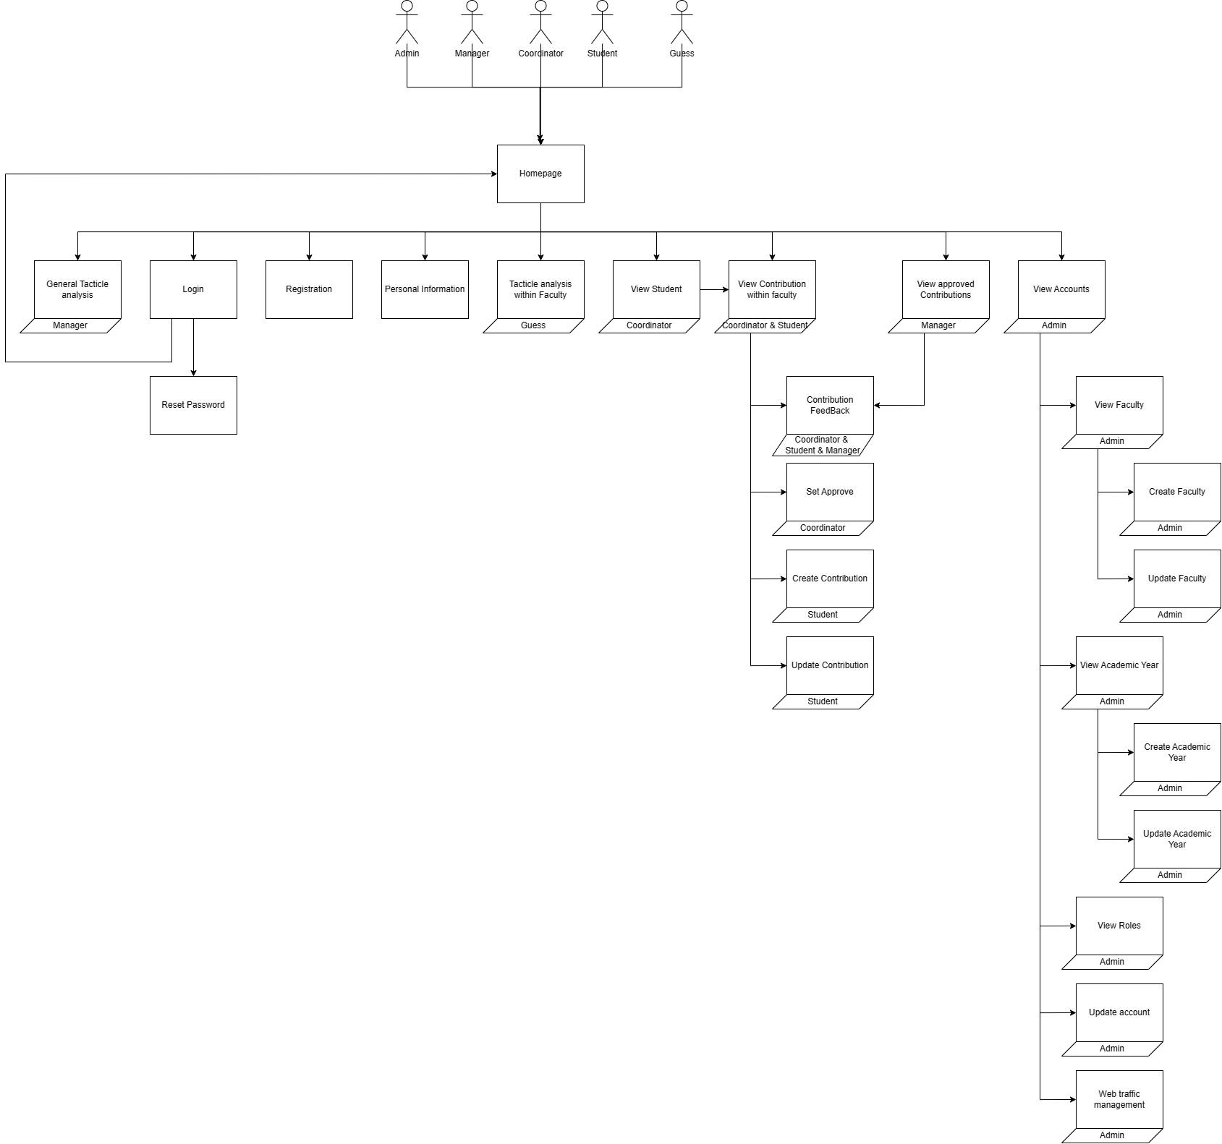

Figure site design

### Web Design

This is the design before we implement the website. Desktops, tablets and mobile phones, the desktop and Tablet will share the wireframe due to similar screens.

**Login page:**

* **Desktop and tablet**

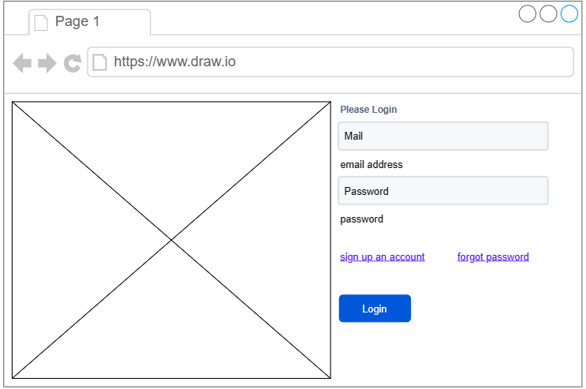

Figure wire frame for login in desktop

* **Mobile phone:**

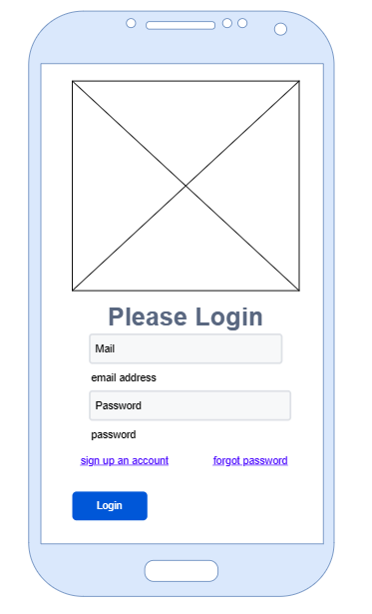

Figure wire frame login in mobile

**Register Page:**

* **Desktop and Tablet**

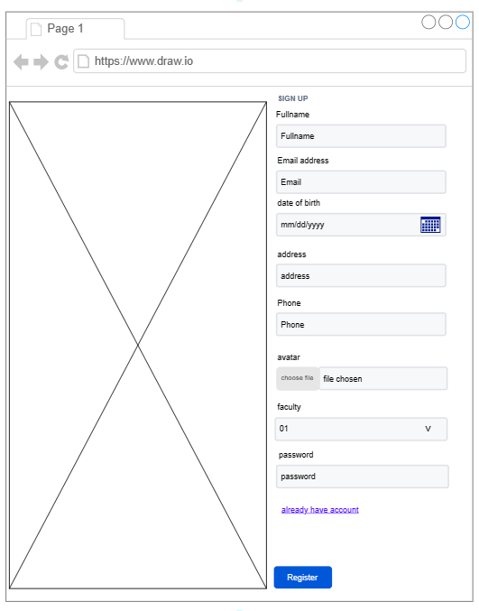

Figure wire frame registration in desktop

* **Mobile Phone:**

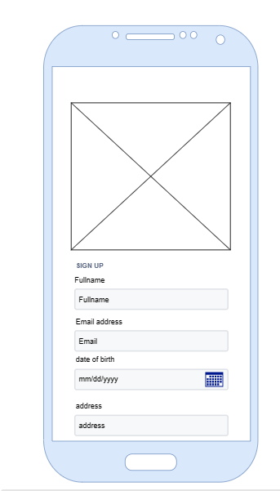

Figure wire frame registration in phone

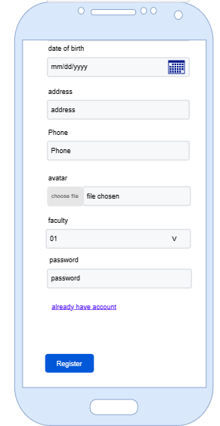

Figure wire frame registration in phone bottom half

**View Accounts**

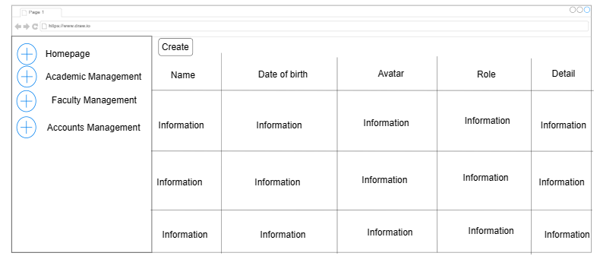

Figure wire frame for admin tables

**Create Contribution**

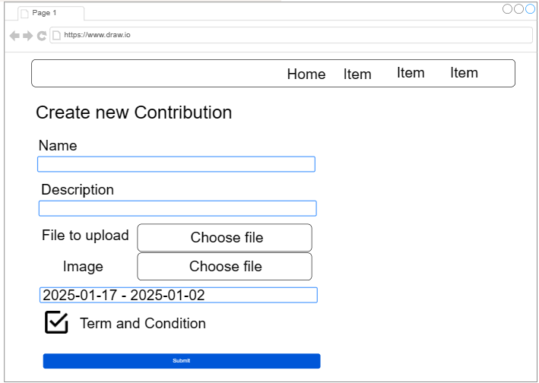

Figure create contribution wire frame

**Feedback View**

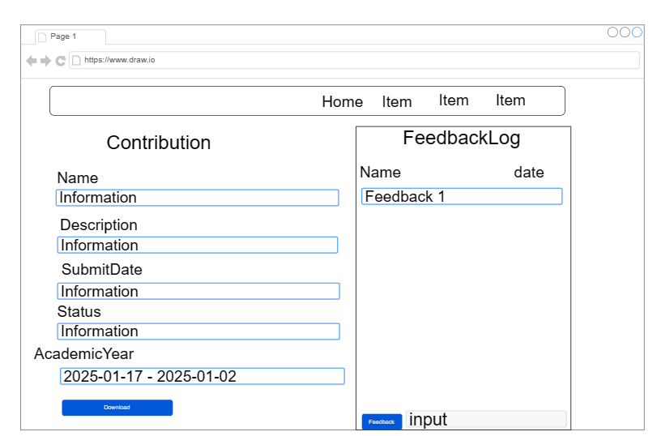

Figure feedback wire frame

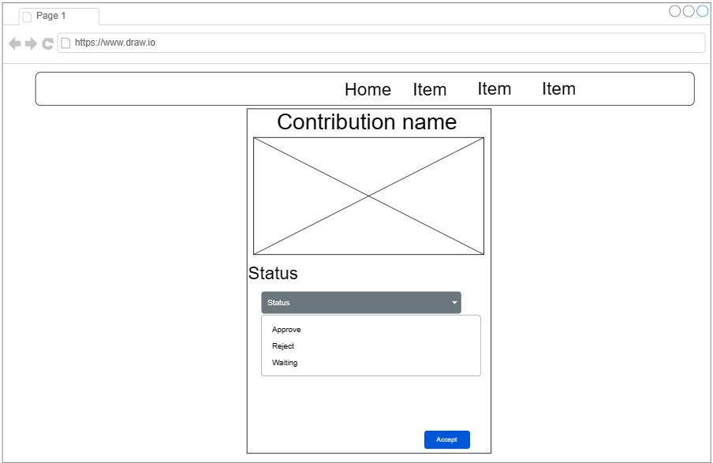

Figure set status wire frame

**HomePage**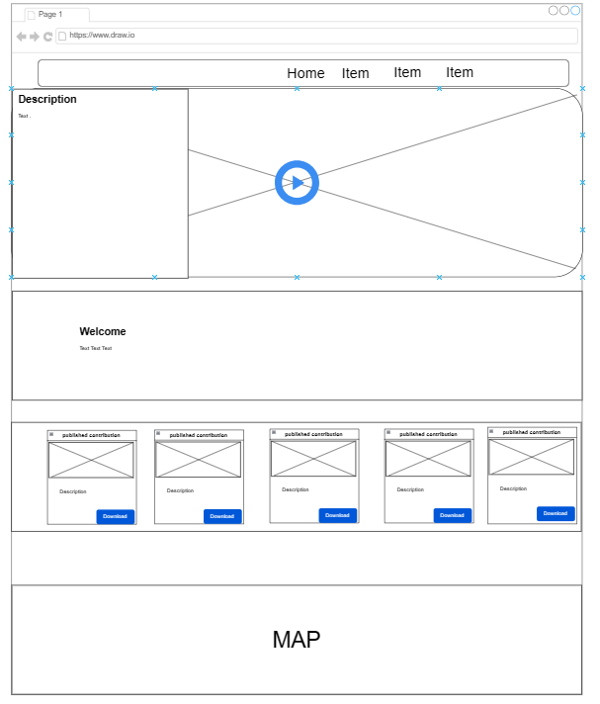

Figure homepage wire frames

# Functionality

The project is built on the Spring Boot framework, Java for the back end, MongoDB for the database, and Windows for operating system development. The project leverages modules and follows the Model-View-Controller (MVC) design pattern to segregate the data modelling from its presentation. This design pattern facilitated seamless collaboration among team members, allowing developers like Khoi and Loc to handle data modelling, routing, and application control. At the same time, data objects were made readily available to the View, allowing designers like Phuoc to focus on refining presentation and enhancing user experience elements. This division of responsibilities streamlined workflow and bolstered productivity throughout the development phase.

## Security

### Hash code for password

The security of the application and its data was a primary focus throughout the project's development. A user authenticates using a password, the password is encrypted using a BCrypt hash, and the account ID in the database is created with a random string containing a number and a word. These enterprise-level security considerations ensure that should the user database table ever be compromised; it would require tremendous computational complexity to crack each account’s password. (*See Code Snippet 1)*

### Role checking

The method checks if a user has specific roles in the system. The checkRole method verifies if the user has a particular role. If the user has that role, it will be able to access the specific page that allows the role to access; otherwise, it throws an "Access Denied" exception. It will enable the user to check multiple roles at once. These methods are essential for controlling access to different system parts based on a user's roles or permissions.

### JSON Web Token

To prevent cases of changing information from viewing the website source code, the system uses Jwt technology (JSON Web Token) to avoid such instances. Jwt technology includes two elements: key and token. Encrypted information is converted into tokens, and the key is stored in the system and used to reverse-encode tokens into information. If token modifications exist, the information cannot be reverse-encrypted, and an exception will be reported to the user.

## Login and Register

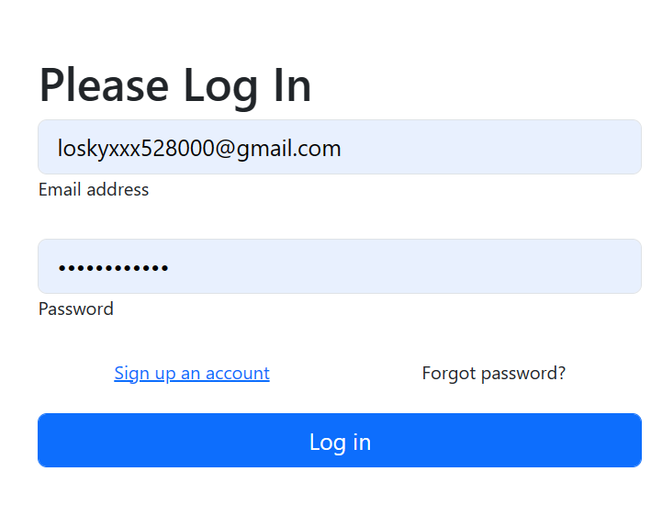

Figure login UI

**Explain**: This is a login page function; this requires the user to use an account that has been signed up before or provided by the website admin. It requires the correct Email and Password.

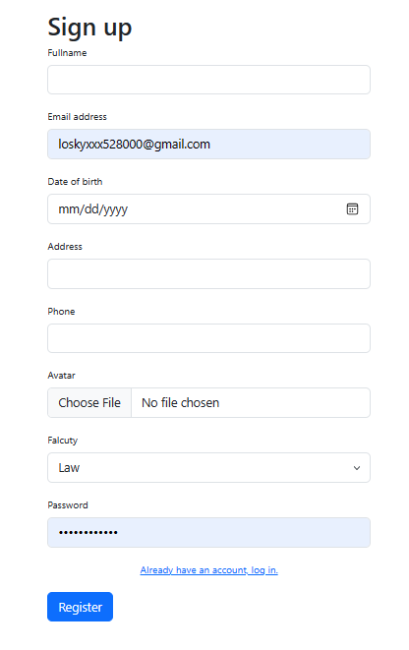

Figure Sign up UI

**Explain**: This is a sign-up view. It requires information from the end user to register an account. It requires a Full name, Email Address, Birth date, Address, Phone number, Avatar picture, Faculty the user wants to register on, and Password. Then, hit the register button to create an account for the quest role. Furthermore, the email address cannot be duplicated with the existing email, meaning the email must be unique for each account. In addition, the password must be complicated. For example, it requires at least eight characters and must have at least 1 number and one uppercase character.

## Submission of Contributions

A `Contribution` module is responsible for creating, viewing and manipulating user-generated content within the site. In the magazine management system, a student user can submit multiple contributions. Meanwhile, a marketing coordinator user can access submissions from students within their respective faculties, where they can view, download, and provide feedback on these contributions. The marketing manager can also view and download student contributions across all faculties.

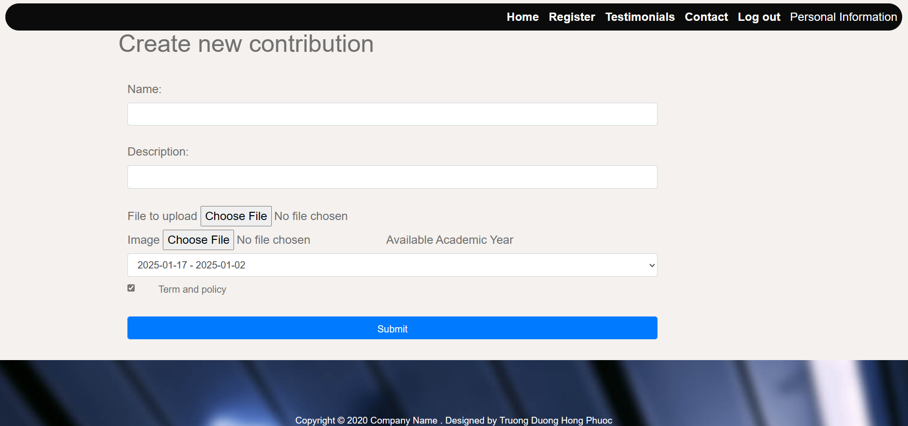

Figure Create contribution UI

This is the submit contribution view, which requires the user to add the contribution's name and description. Upload the file, which is necessary for Docx and Doc extension for the file, and the image to show if the contribution is public on the homepage. They also must accept the terms and policy to submit the contribution. In addition, the submit button only shows when the check box agrees with the term and the policy is checked. The blank must be filled in before submission as well.

## Update Contribution

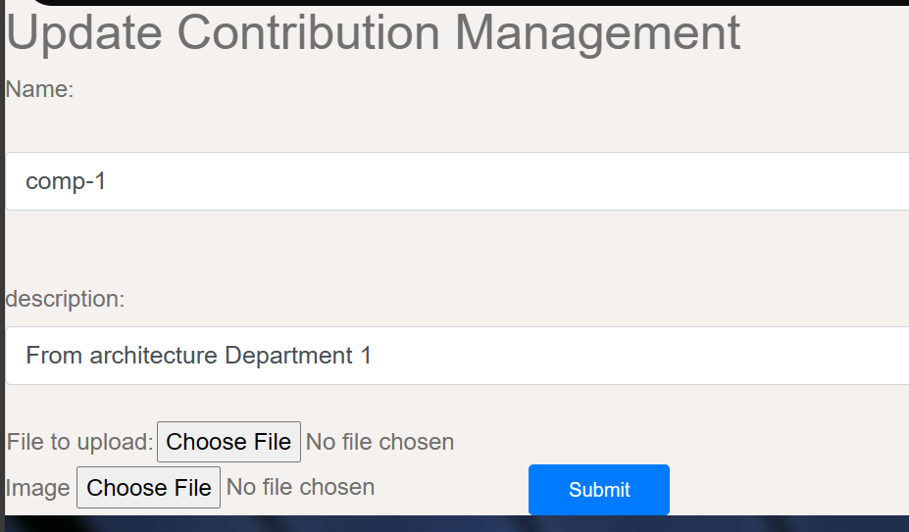

Figure Update contribution UI

In case the user wants to change something in their contribution. This updated contribution view allows users to change the name of the contribution and description, as well as the file and images.

## Delete Contribution:

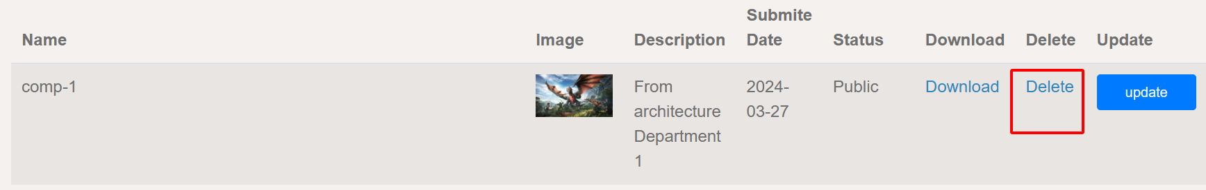

Figure Delete contribution UI

In some cases, students can archive the function given their contributions if they want to delete the contribution. They are able to delete it if they wish to.

## Feedback Contribution

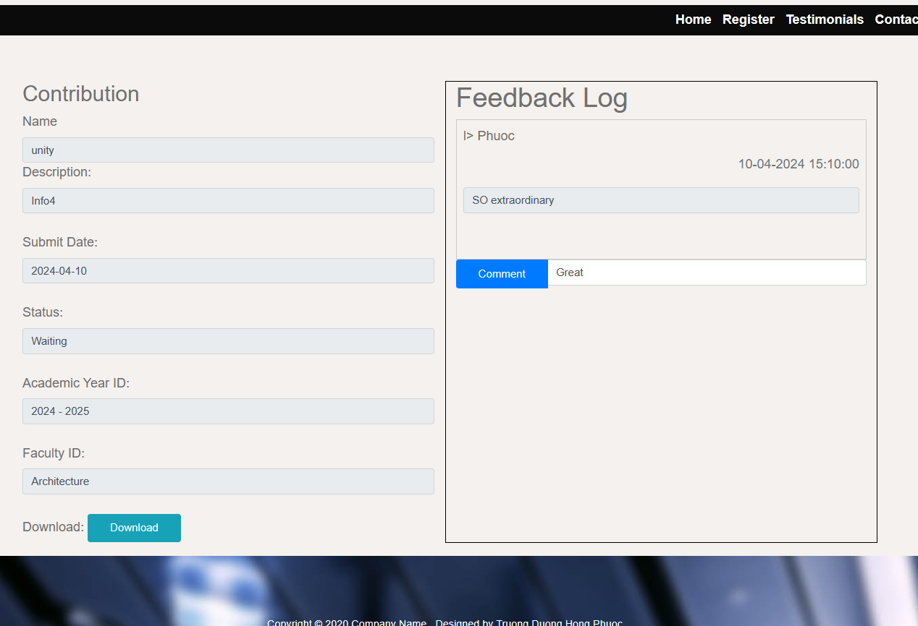

Figure Feedback UI

This is feedback on a contribution. The contribution information will be exposed on the left if they want to check the content. They can download the file here as well. On the right side is the comment feature coordinator, and students are able to comment on the contribution. The name and time will be exposed.

## Reset password and Forgot password:

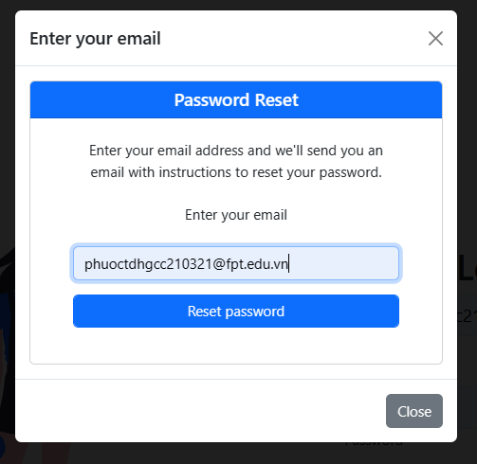

Figure forgot password form

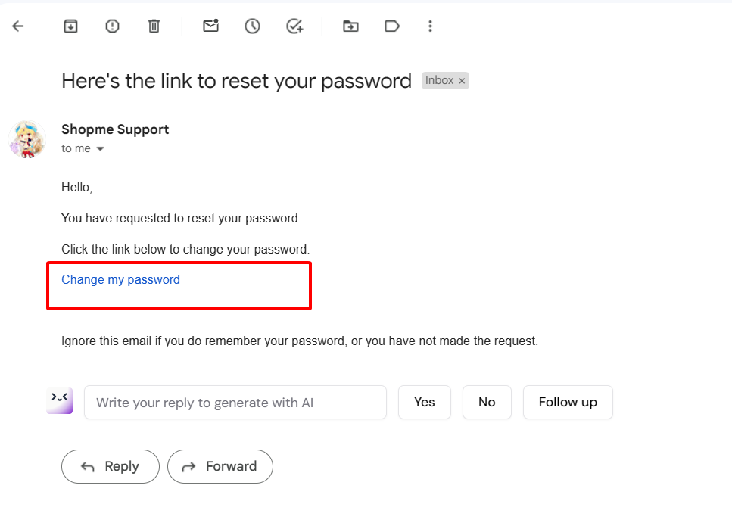

Figure email that send to reset password

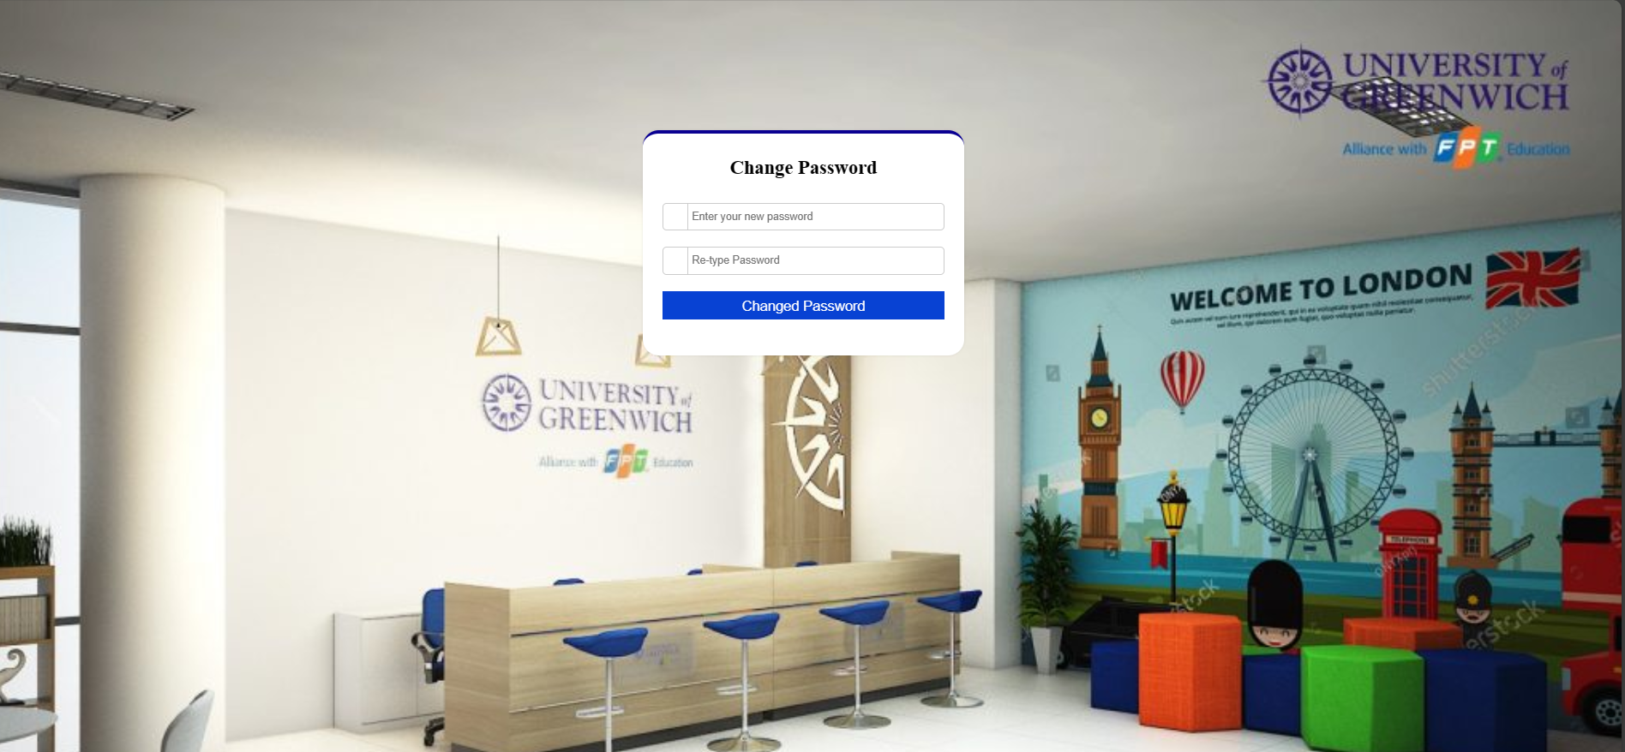

Figure reset password UI

**Explain**: the feature of forgot takes many views to use for security purposes, for example, to reset the password of an account. It requires typing in the email address to send an email with the link to get in the view to change the email password that the user just types in. After that, they are able to create a new, fresh password.

## View contribution and public contribution / Filter by Faculty and Academic Year

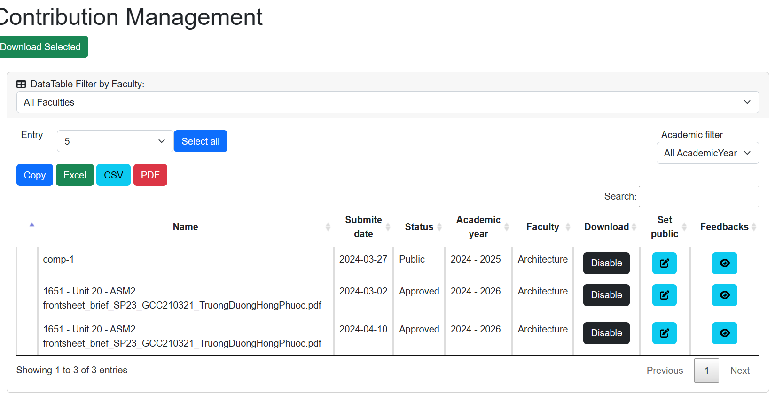

Figure copntribution managent UI

**Explain**: This is a view of Contributions that the coordinator has approved to let the manager publicise the contribution. The download function is currently being disabled when the academic year is not finally closed yet! It can search the contribution and download an Excel CSV table pdf. It also provides a filter by academic year and faculty. For the download Selected. The academic year of contributions must end before being able to download in a zip file. To demonstrate this, I will change the time that I am able to download 2 of the contributions due to the different academic year.

## First Login Animation



Figure first login animation welcome

This is the first login feature to welcome new users. The animation only plays one time in an account. After the animation, the user will be transparent to the homepage so they can use it as usual.

## Approve and Public contribution

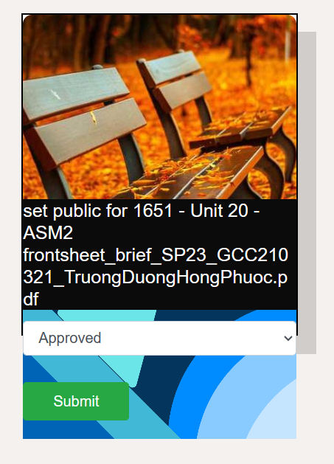

Figure Set status for contribution UI

**Explain**: This is the page for approving the contribution. The coordinator is a role that can access this page by viewing a student's contributions. This page allows the coordinator to approve or reject a contribution. The approved contribution will be sent to the contribution views of the Manager. The image is randomised for a better user experience so that users do not get bored. After they are considered, they can hit the submit button to set the contribution status.

## Statistics and Exception Reports

Various reports exist within the academic management system. One example is the Faculty Statistics and Exception Reports, which show the amount of contributions per faculty per academic year. These reports are available for the marketing manager and guest users.

### Guest:

**Statistics**: The image below is an example of a statistics report for the guest account, and this is a report for the architecture faculty; all reports for others are the same charts as this one.

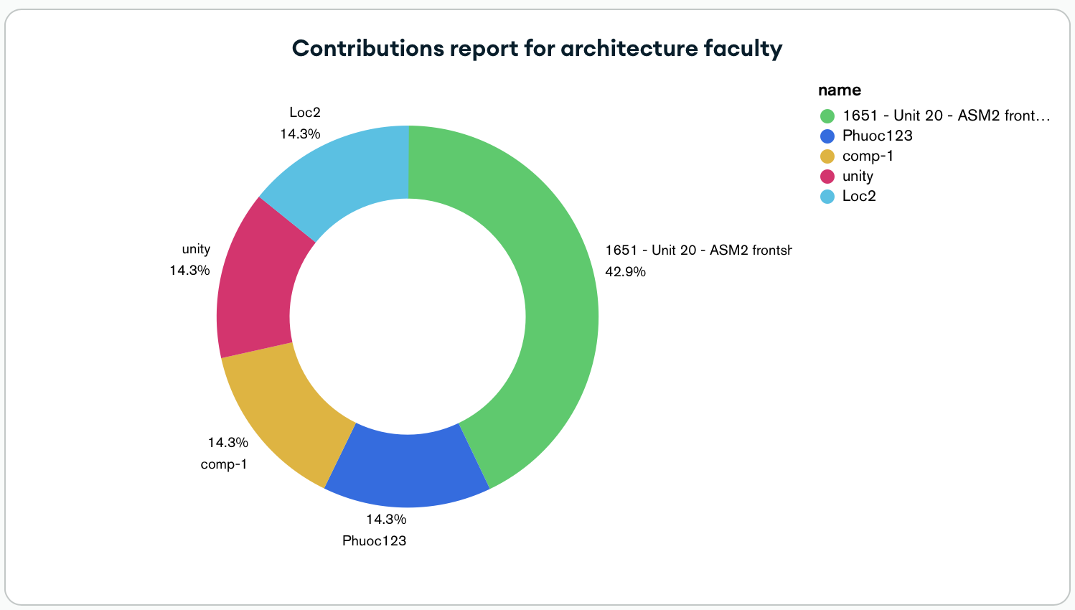

Figure tacticle analystic for a faculty

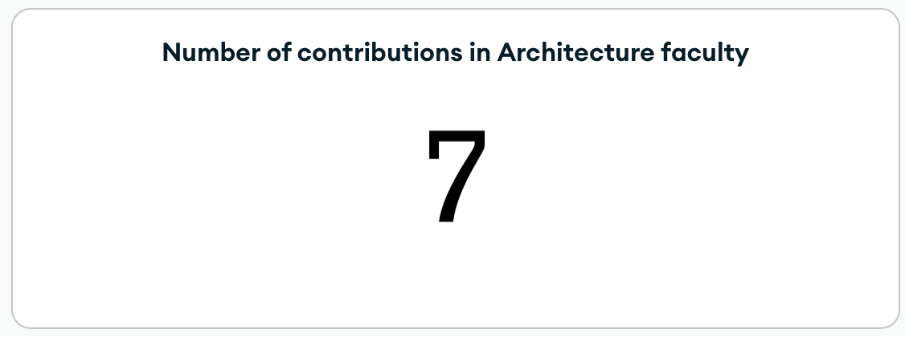

Figure tacticle analystic number of contribution in a faculty

### Marketing Manager:

The statistics and exception reports below are only available for the Marketing Manager

**Statistics report**:

* The chart below shows the percentage of approved contributions still awaiting approval and public contributions from all faculties.

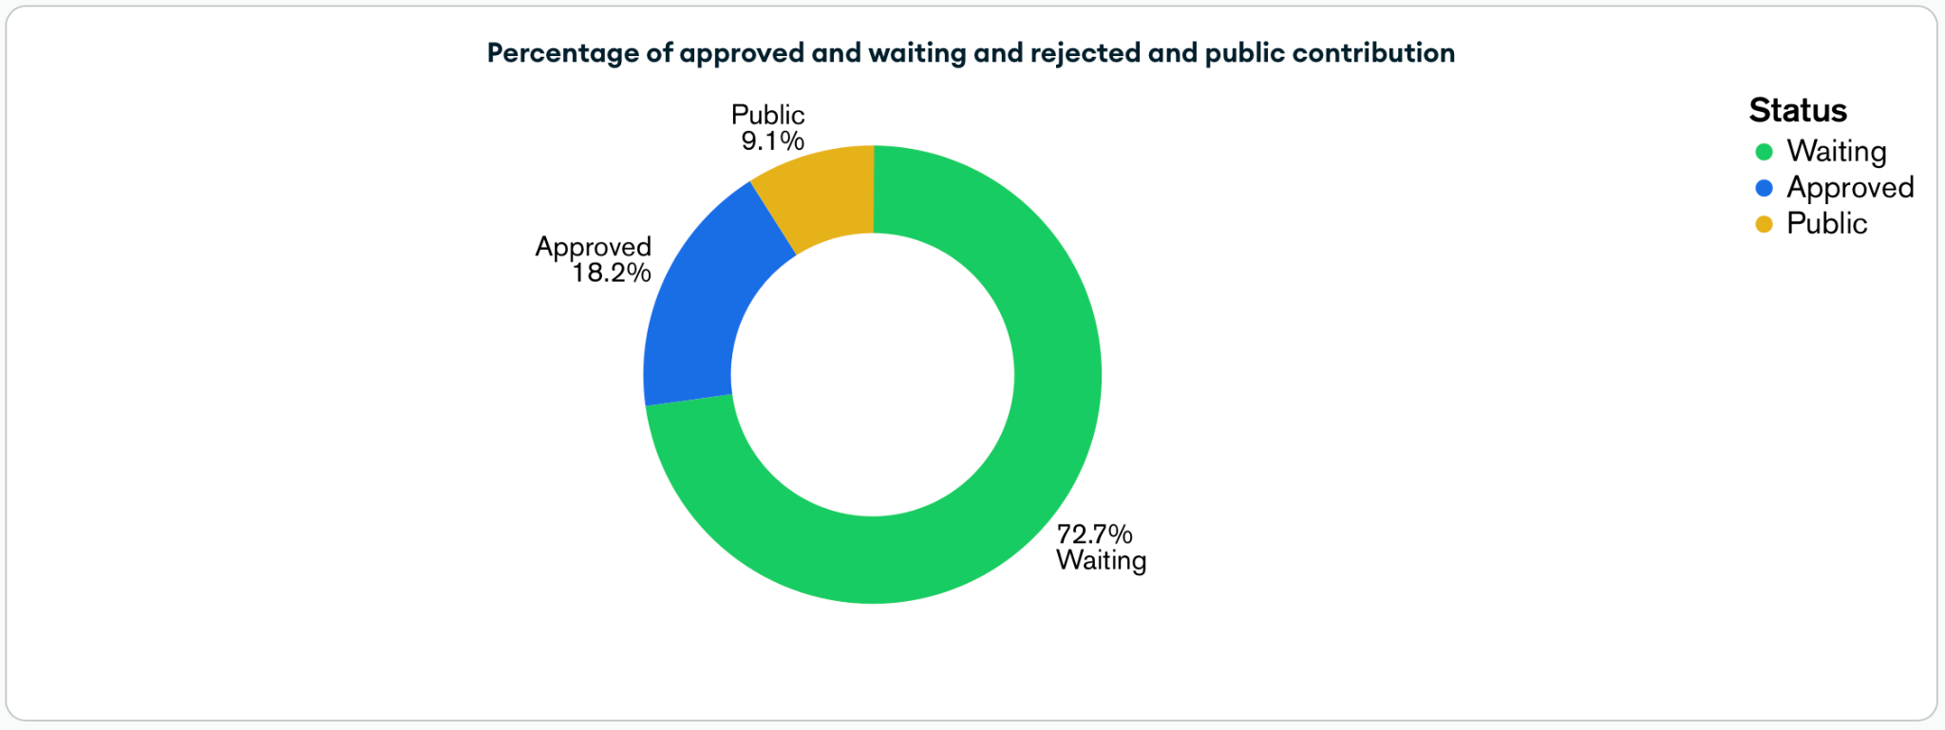

Figure precemtage of each status contribution

* The chart below shows the number of contributions within each Faculty for each academic year.

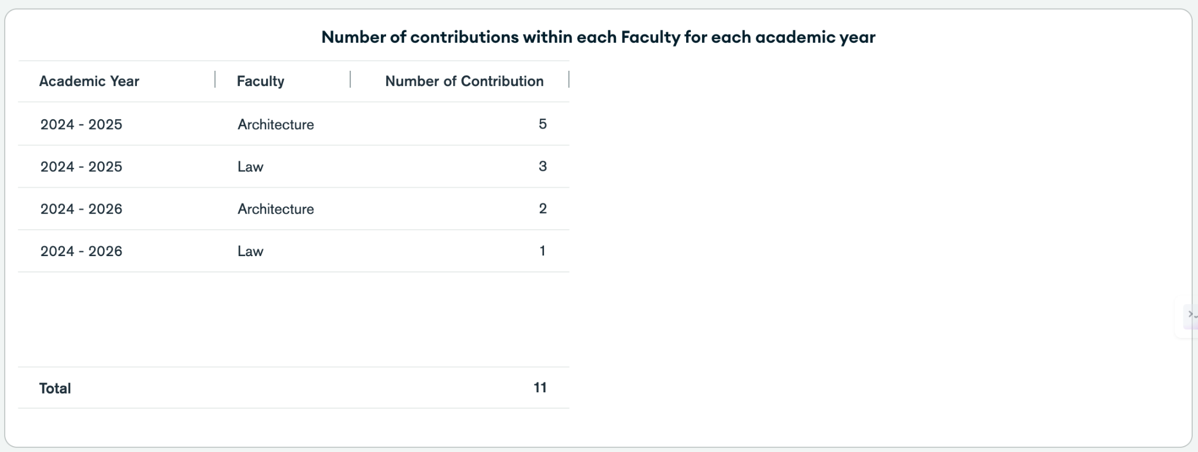

Figure number of contribution within faculty for each academic year

* The chart below shows the percentage of contributions by each faculty member for any academic year.

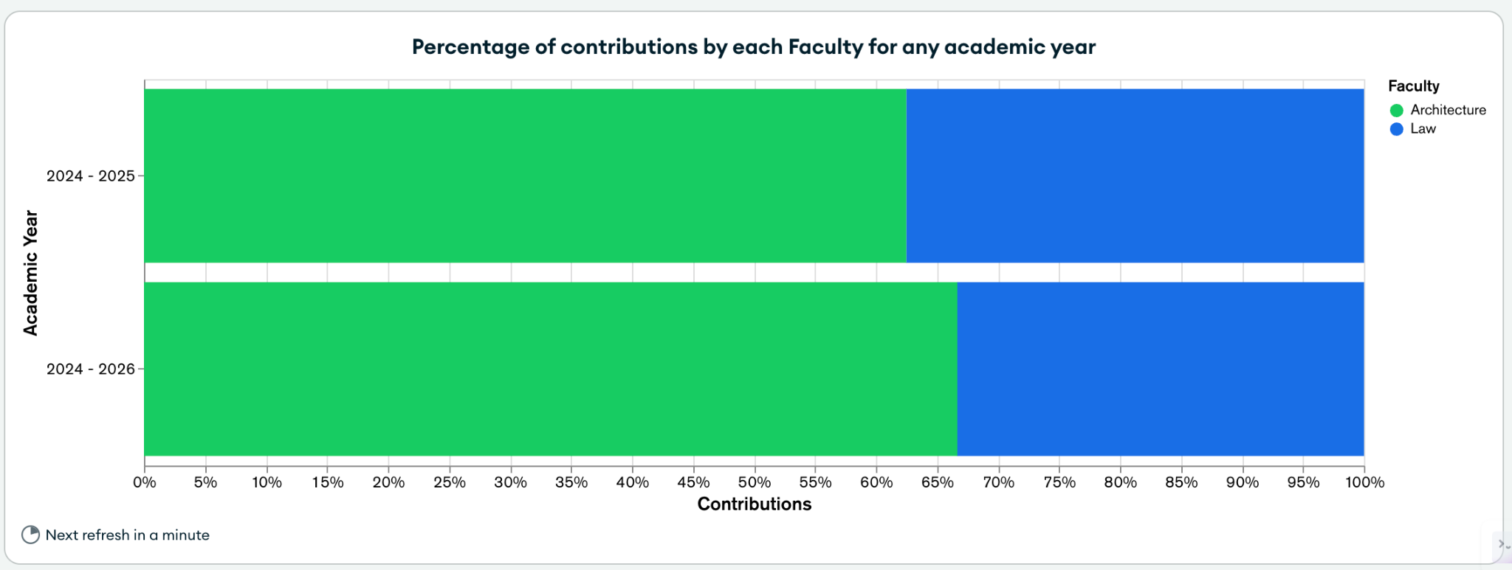

Figure contribution of faculties for any academic year

* The chart below shows the number of contributors within each Faculty for each academic year.

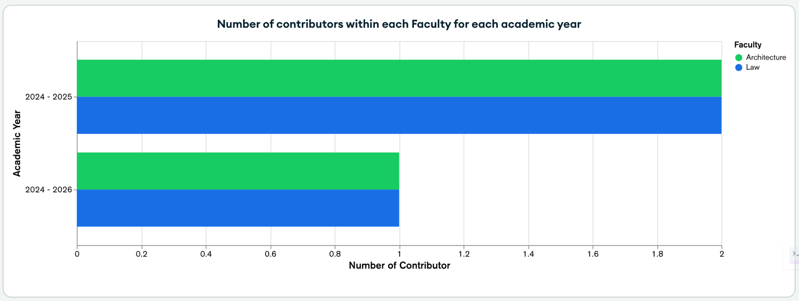

Figure number of contributor each faculty each academic years

### Exception reports:

* The chart below shows the contributions without a comment.

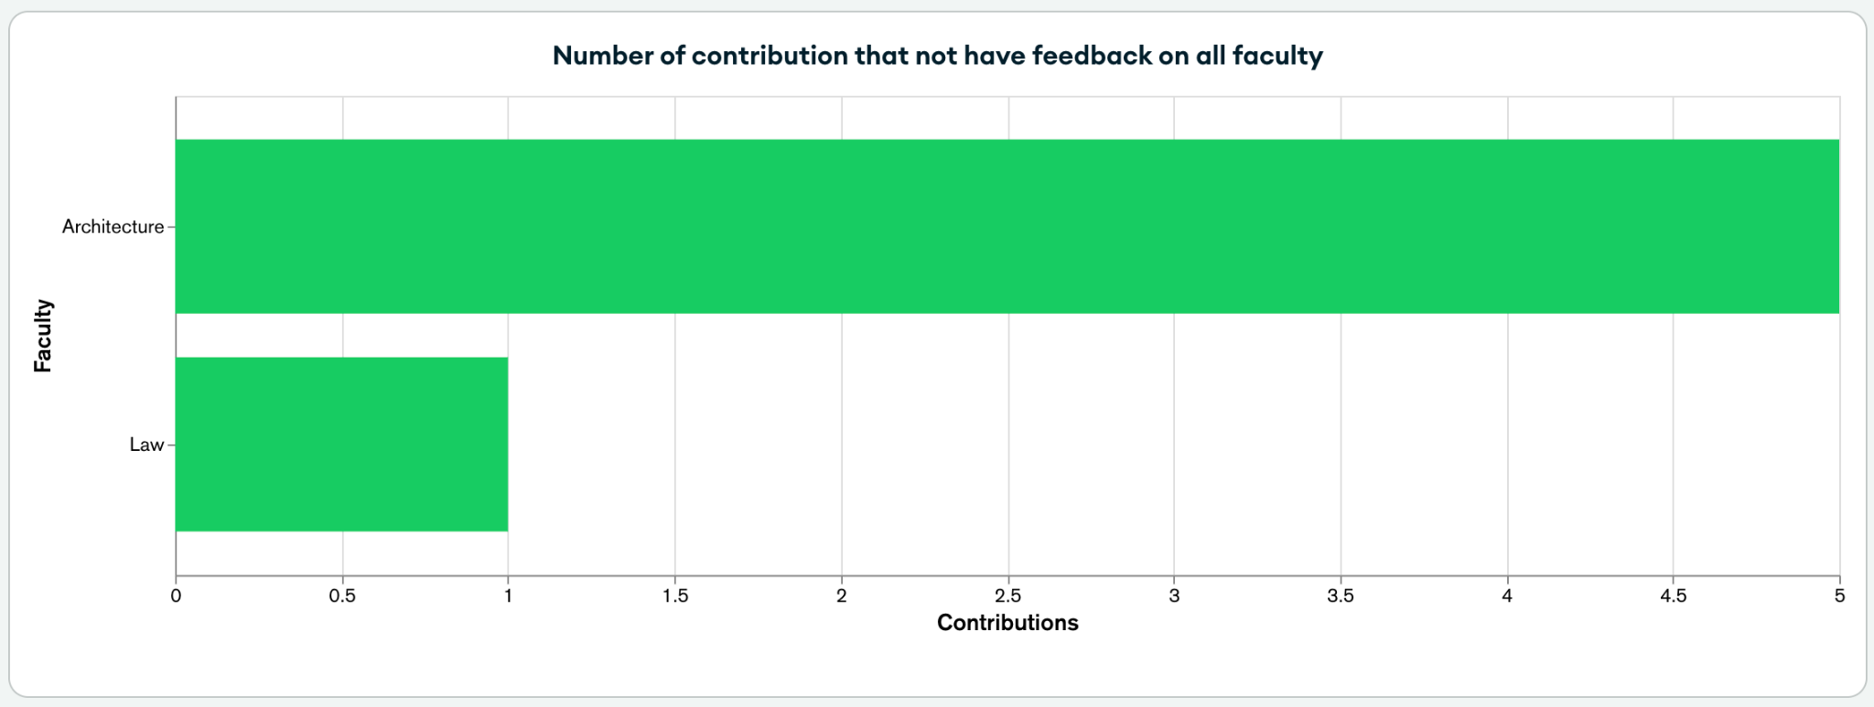

Figure number of contribution withou feedback

* The chart below shows the contributions without a comment after 14 days.

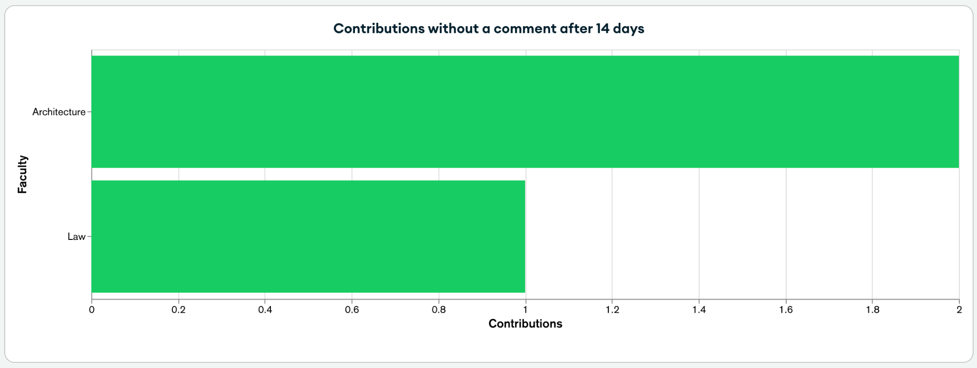

Figure contribution without comment after 14 days

The magazine management system also uses Google Analytics to capture usage metrics across the platform. The administrator can view a Google Analytics dashboard within their dashboard and view advanced metrics.

## UML diagrams

Using the modular Spring Boot Framework, there were no complex dependencies between the various functionality of the system. The users’ properties are accessed through an authentication service, and the access control attaches itself to MVC events within the system. By architecting this enterprise solution, we avoided a monolithic application, spaghetti code and repeated conditional statements such as the following in our modules.

### Use case

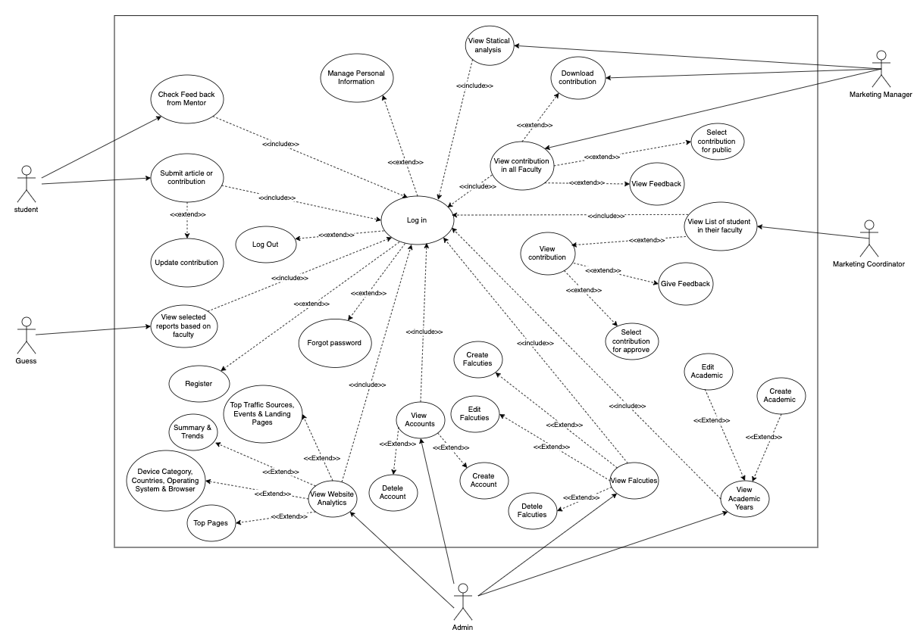

Figure use case

### Class Diagram

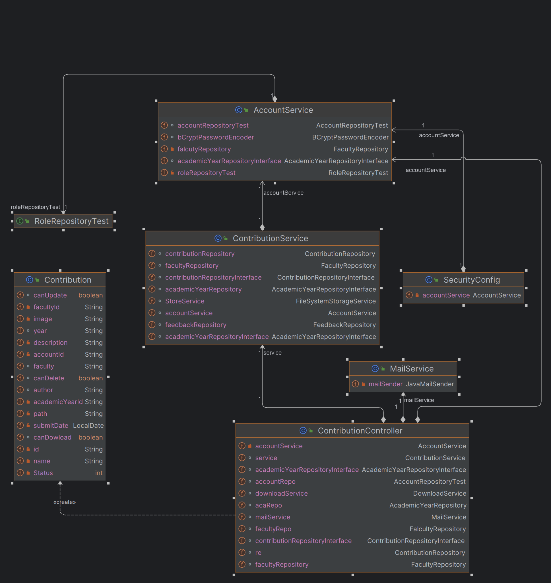

Figure class diagram

## Website Analytics

Google Analytics (GA) is embedded on the AMS website to get website analytics in real-time and generate reports such as active users, most visited pages, website traffic, user origin, browser types used to visit the website, etc. These reports can be easily seen on the Google Analytics dashboard. However, to show Google Analytics dashboard elements and required reports on our Academic Management System website directly, we created custom web elements using Polymer (a Javascript framework). This helped us make the required elements to display the reports on the MMS website. Polymer uses Google Analytics API within the framework to get data from Google in JSON format. The JSON data is then represented in the form of tables, charts and graphs by creating polymer elements. These elements are reusable and provide high maintainability. It is also possible to sort the data and get different metrics and dimensions for required analytics. For security purposes, it uses Google sign-in API for authentication and is only accessible by an account with an admin role in the system.

### Summary and Trends

The figure below shows the most active user on a website in real-time; this dashboard is only accessible to the admin user type of the system. As mentioned above, a second layer of security verifies if the admin user is authorised to access the data by confirming the user’s Google identity.

|  |
| --- |
| Figure summary traffic analystic |

|  |
| --- |
|  |

Table trends analystic

### Device Category, Countries, Operating System and Browser

The graphs below show the category of device, the browser and the operating system that the user uses to access the web application. Moreover, the country where the user accesses the web application is also in one of the graphs below. Charts show data over the last 30 days, and the chart shows up-to-date data on 20th April 2024.

|  |
| --- |
|  |

Table device category

|  |
| --- |
|  |

Table operting system

|  |
| --- |
|  |

Table country access to website

|  |
| --- |
|  |

Table browser use to access website

### Top Traffic Sources, Events and Landing Pages

The report below shows top traffic sources, events, and landing pages on our website over the last 30 days. The chart shows up-to-date data on 20th April 2024.

|  |
| --- |
|  |

Table traffic sources

|  |
| --- |
|  |

Table Top events analystics

|  |
| --- |
|  |

Table analistic Landing pages

### Top Pages

The pie chart represents the top pages of the website. The colours in the pie chart represent the specific page of a website. The table below also shows the same result; it shows each page's total number of views instead of their percentage. The polymer element showing the results uses ga: Pageviews as dimension and uses ga:pagepath as metrics.

|  |
| --- |
|  |

Table top pages analystics

## Further Developments

Reflecting on the project, Team Prime discussed ways to improve the system had there been more resources. One suggestion was to implement the system's ‘Drag and Drop’ file transfer functionality. This is an increasingly common method of submitting user-generated content utilised by famous websites. Initially, we attempted to implement the ‘View Feedback’ section into a Modal and populate it without the need to change or reload pages. Unfortunately, as time progressed, we had to cut back on this functionality to ensure the stakeholder requirements were met.

Function set role that can allow which role can access what page

## Code Snippets

* **Snippet #1 - Password BCrypt Hashing**

|  |
| --- |
|  |

Table password Bcrypt hashing Code

* ***Snippet #2 - Login and Log out***

|  |
| --- |
|  |
|  |

Table Login and log out Code

* ***Snippet #3 - Roles checking***

|  |
| --- |
|  |

Table check roles code

* **Snippet #4 - Submit Contribution**

|  |
| --- |
|  |

Table submit contribution code

* ***Snippet #5 - Update Contribution***

|  |
| --- |
|  |

Table update contribution code

* ***Snippet #6 - Delete Contribution***

|  |
| --- |
|  |

Table delete contribution code

* ***Snippet #7 - Register***

|  |
| --- |
|  |

Table registration code

* ***Snippet#11 - Closure day restriction on Submit Contribution and Final Closure day restrict on Update Contribution***

|  |
| --- |
|  |

Table submit contibution contraints with academic year

* ***Snippet #12 - View feedback on contributions***

|  |
| --- |
|  |

Table view feedback contribution code

* ***Snippet #13 - Forgot password***

|  |
| --- |
|  |

Table forgor password code

|  |
| --- |
|  |

Table reset password code

* ***Snippet #14 - Approve and Public contribution***

|  |
| --- |
|  |

Table change status contribution code

* ***Snippet #15 - Filter for Contribution Table***

|  |
| --- |
|  |

Table fillter table contribition code

* ***Snippet #16 - Send Mail***

|  |
| --- |
|  |

Table send mail code

* ***Snippet #17 - Verify token input***

|  |
| --- |
|  |

Table token input code

* ***Snippet #18 - Download In Zip file***

|  |
| --- |
|  |

Table download in zip file

# Testing

Testing was conducted concurrently with the development of the proposed application to guarantee robustness and alignment with client specifications. The following sections outline the elements that underwent testing and the corresponding results.

## Test plan

|  |  |  |  |  |  |  |  |
| --- | --- | --- | --- | --- | --- | --- | --- |
| **Date** | **Test**  **Number** | **Purpose** | **Process** | **Expected result** | **Actual result** | **Pass/Fail** | **Action**  **Taken** |
| 17/04/2024 | 01 | Verify that the admin can create a new faculty | 1. Log in as an admin  2. Go to the admin page and go to the "faculty management" section  3. Click on the Create button to go to the Create Faculty page  4. Fill in the required details and submit | A new faculty entry should be created and displayed in the faculty list | As expected | Pass | No further action is required |
| 17/04/2024 | 02 | Verify that information is displayed when the admin goes to update the faculty page | 1. Log in as an admin  2. Go to "faculty management" section  3. Select a faculty from the list  4. Click on "update" | Editable fields for the faculty details should be displayed for modification. | As expected | Pass | No further action is required |
| 17/04/2024 | 03 | Verify that the admin can update the faculty | 1. Log in as an admin  2. Go to "faculty management" section  3. Select a faculty from the list  4. Modify details  5. Save the information | Faculty information should be updated and saved successfully | As expected | Pass | No further action is required |
| 17/04/2024 | 04 | Verify that the admin can delete faculty | 1. Log in as an admin  2. Go to "faculty management" section  3. Select a faculty from the list  4. Click on "delete." | A confirmation prompt should appear asking to confirm the deletion  Upon confirmation, the faculty should be deleted | As expected | Pass | No further action is required |
| 17/04/2024 | 05 | Verify that the admin can create a new academic year | 1. Log in as an admin  2. Go to the academic year management section  3. Click on create academic year  4. Fill in the required details and submit | A new academic year entry should be created and displayed in the academic year list. | As expected | Pass | No further action is required |
| 17/04/2024 | 06 | Verify that information is displayed when the admin goes to update the academic year page | 1. Log in as an admin  2. Go to "academic year management" section  3. Select an academic year from the list  4. Click on "update" | Editable fields for the academic year details should be displayed for modification. | As expected | Pass | No further action is required |
| 17/04/2024 | 07 | Verify that the admin can update the academic year | 1. Log in as an admin  2. Go to "academic year management" section  3. Select an academic year from the list  4. Modify details  5. Save the information | Academic year information should be updated and saved successfully | As expected | Pass | No further action is required |
| 17/04/2024 | 08 | Verify that the admin can delete the academic year | 1. Log in as an admin  2. Go to "academic year management" section  3. Select an academic year from the list  4. Click on "delete." | A confirmation prompt should appear asking to confirm the deletion  Upon confirmation, the academic year should be deleted | As expected | Pass | No further action is required |
| 17/04/2024 | 09 | Verify that all users with accounts can log out | 1. Login as any role  2. Find the "log out" button and click | The user should be logged out, and the last session will be saved | As expected | Pass | No further action is required |
| 17/04/2024 | 10 | Verify that the unauthorised user can create a new guest account | 1. Go to the registration page  2. Fill in the username and password  3. Submit the registration form | A new user account should be created | As expected | Pass | No further action is required |
| 17/04/2024 | 11 | Verify that the user cannot create an account with a weak password | 1. Go to the registration page  2. Enter a weak password  3. Submit the registration form | The system should display an error message indicating that the password is too weak. | As expected | Pass | No further action is required |
| 17/04/2024 | 12 | Verify that the admin can create an account for all roles in the system | 1. Login as admin  2. Admin navigates to the registration page  3. Enters account details  4. Submit the registration form | A new high-priority account should be created | As expected | Pass | No further action is required |
| 17/04/2024 | 13 | Verify that the hello animation appeared when the account logs in for the first time | 1. Register a new account  2. Navigate to the login page  3. Enter username and password  4. Click "login" | The user should be logged in successfully, and the animation should appear. | As expected | Pass | No further action is required |
| 17/04/2024 | 14 | Verify that all users can request to reset the password | 1. Go to the login page  2. Navigate to the "forgot password" page  3. Enter email address  4. Submit the form | The user should receive an email with instructions to reset the password | As expected | Pass | No further action is required |
| 17/04/2024 | 15 | Verify that the user with an account can reset the password after receiving the email | 1. Go to the login page  2. Click the reset password link from the email  3. Enter a new password  4. Submit the form | The user should be able to reset the password successfully | As expected | Pass | No further action is required |
| 17/04/2024 | 16 | Verify that information is protected by jwt (JSON web token) | 1. User attempts to make updates in edit source code from the browser  2. Open the developed tool in the browser and change the information.  3. Submit the changed information | The system shouldn’t be able to use the information to process. | As expected | Pass | No further action is required |
| 17/04/2024 | 17 | Verify that all users with accounts can update account information | 1. Login as any role  2. Navigate to the "personal information" page  3. Edit account details  4. Save changes | User account information should be updated successfully | As expected | Pass | No further action is required |
| 17/04/2024 | 18 | Verify that admin can set user role for account | 1. Login as admin  2. Admin navigates to the "set role" section  3. Select the user to modify the role  4. Sets new role and saves changes | User role should be updated as per the admin's selection | As expected | Pass | No further action is required |
| 17/04/2024 | 19 | Please verify that the marketing coordinator cannot change status after it is set to public | 1. Login as marketing coordinator  2. Navigate to the contribution  3. Attempt to change status after it is set to "public" | The system should not allow changing the status after it is set to "public.” | As expected | Pass | No further action is required |
| 17/04/2024 | 20 | Verify that student cannot create contribution when not fill in blanks | 1. Login as student  2. Navigate to the contribution creation page  3. Leave required fields blank  4. Submit the form | The system should display an error message indicating that required fields cannot be blank. | As expected | Pass | No further action is required |
| 17/04/2024 | 21 | Verify that the student cannot create a contribution before accepting the terms | 1. Login as student  2. Attempt to create a contribution without accepting terms and conditions | The system should only allow contribution creation if it accepts terms and conditions. | As expected | Pass | No further action is required |
| 17/04/2024 | 22 | Verify that the student cannot upload files except doc, docx | 1. Login as student  2. Attempt to upload a file that is not in doc or docx format | The system should display an error message indicating that only doc and docx files are allowed. | As expected | Pass | No further action is required |
| 17/04/2024 | 23 | Verify that the student cannot create a contribution after the closure date | 1. Login as student  2. Attempt to create a contribution after the closure date | The system should not allow contributions to be made after the closure date. | As expected | Pass | No further action is required |
| 17/04/2024 | 24 | Verify that admin can create within academic available | 1. Login as admin  2. Navigate to the admin page  3. Create a contribution within the available academic year | The system should allow the creation of a contribution within the available academic year. | As expected | Pass | No further action is required |
| 17/04/2024 | 25 | Verify that the system sends mail to marketing coordinators with the same faculty | 1. Login as student  2. View student work  3. Submit a contribution | The system should send an email notification to the marketing coordinator of the same faculty. | As expected | Pass | No further action is required |
| 17/04/2024 | 26 | Verify that the student can update when the academic year is available | 1. Login as student  2. Navigate to the contribution  3. Edit the contribution details  4. Save changes | The system should allow contributions to be updated when the academic year is available. | As expected | Pass | No further action is required |
| 17/04/2024 | 27 | Verify that the student cannot update after the final close date | 1. Login as student  2. Attempt to update a contribution after the final close date | The system should not allow updating a contribution after the final close date. | As expected | Pass | No further action is required |
| 17/04/2024 | 28 | Verify that the student can delete a contribution | 1. Login as student  2. Navigate to the view student work page  3. Click on "delete" any submitted contribution | A confirmation prompt should appear asking to confirm the deletion  Upon confirmation, the contribution should be deleted | As expected | Pass | No further action is required |
| 17/04/2024 | 29 | Verify that student view their contribution | 1. Login as student  2. Navigate to the view work page | The student should be able to view their contribution | As expected | Pass | No further action is required |
| 17/04/2024 | 30 | Please verify that the marketing coordinator views their student's contribution | 1. Login as marketing manager  2. Go to view the student page  3. Choose students to view their contribution. | Marketing coordinator should be able to view the contributions of their students. | As expected | Pass | No further action is required |
| 17/04/2024 | 31 | Verify that all user that has accounts can download public contributions in a file on the homepage | 1. Login as any role  2. Navigate to the contribution list on the homepage  3. Download a student's contribution as a file | Users should be able to download a student's contribution as a file | As expected | Pass | No further action is required |
| 17/04/2024 | 32 | Verify that all users can view public contribution | 1. Navigate to the public contributions on the homepage | Users should be able to view public contributions | As expected | Pass | No further action is required |
| 17/04/2024 | 33 | Verify that the marketing manager views the approved contribution | 1. Login as marketing manager  2. Access manage view  3. Navigate to the approved contributions page | User should be able to view approved contributions | As expected | Pass | No further action is required |
| 17/04/2024 | 34 | Verify that the marketing manager can download contributions in the file | 1. Login as marketing manager  1. Navigate to the approved contributions list  2. Download an approved contribution as a file | User should be able to download contributions in tables | As expected | Pass | No further action is required |
| 17/04/2024 | 35 | Verify that marketing coordinators can download contributions in the zip | 1. Login as marketing coordinator  2. Navigate to the approved contributions view  3. Select multiple contributions  4. Download as a zip file | The marketing coordinator should be able to download multiple contributions as a zip file. | As expected | Pass | No further action is required |
| 17/04/2024 | 36 | Verify that the marketing manager can filter by academic year | 1. Login as marketing manager  2. Navigate to the contributions list  3. Filter contributions by an academic year | Contributions should be filtered based on the selected academic year | As expected | Pass | No further action is required |
| 17/04/2024 | 37 | Verify that the marketing manager can filter by faculty | 1. Login as marketing manager  2. Navigate to the contributions list  3. Filter contributions by a faculty | Contributions should be filtered based on the selected faculty | As expected | Pass | No further action is required |
| 17/04/2024 | 38 | Verify that the marketing coordinator and student can view the feedback provided | 1. Login as different roles, marketing coordinator and student  2. Navigate to the feedback page | User should be able to view the details of the selected feedback | As expected | Pass | No further action is required |
| 17/04/2024 | 39 | Verify that the marketing coordinator and student create feedback within 14 days | 1. Login as different roles, marketing coordinator and student  2. view the contribution  3. Navigate to the feedback page  4. Create new feedback | Feedback should be successfully submitted if done within 14 days of the event. | As expected | Pass | No further action is required |
| 17/04/2024 | 40 | Verify that the marketing coordinator and student cannot give feedback after 14 days from submit day | 1. Login as different roles, marketing coordinator and student  2. View the contribution  3. Navigate to the feedback page  4. Attempt to create new feedback | The system should not allow feedback after 14 days from submit day | As expected | Pass | No further action is required |
| 17/04/2024 | 41 | Verify role-based access to pages | 1. Log in as different user roles (admin, marketing coordinator, student)  2. Attempt to access various pages | Users should only be able to access pages based on their assigned roles | As expected | Pass | No further action is required |
| 17/04/2024 | 42 | Verify that the website has responsiveness on tablet, mobile and desktop | 1. Access the system on tablet, mobile, and desktop devices  2. Verify that ui elements adjust and display correctly | UI elements should adjust and display correctly on tablet, mobile, and desktop devices. | As expected | Pass | No further action is required |
| 17/04/2024 | 43 | Verify that the system can load the animation display | 1. Navigate to pages  2. Go to different pages | Loading animation should be displayed during data loading or transitions | As expected | Pass | No further action is required |
| 17/04/2024 | 44 | Verify that the marketing manager and admin can download table data in different formats | 1. log in to a different role, which is the marketing manager and admin  2. Navigate to a management page (contributions, academic years, faculty) with downloadable options (CSV, excel, pdf)  3. Download table data in each format | Table data should be downloaded successfully in CSV, Excel, and PDF formats. | As expected | Pass | No further action is required |
| 17/04/2024 | 45 | Verify that guests can view statistics | 1. Login as guest  2. Navigate to the statistics report page | Guest should be able to view statistics | As expected | Pass | No further action is required |
| 17/04/2024 | 46 | Verify that the admin can view website analytics | 1. Login as admin  2. Access to the admin page  3. Navigate to the website analytics page | Admin should be able to view website traffic statistics | As expected | Pass | No further action is required |
| 17/04/2024 | 47 | Verify that the marketing manager can view the statistics analysis report | 1. Log in as marketing manager or equivalent role  2. Navigate to the statistical analysis page | A marketing manager should be able to view specific statistics analysis reports relevant to their role. | As expected | Pass | No further action is required |
| 17/04/2024 | 48 | Verify that the student can upload an image to submit a contribution | 1. Login as student  2. Go to the view work page  3. Submit a new contribution and add an image | Students who successfully submit new contributions will be able to view the work page. | As expected | Pass | No further action is required |
| 17/04/2024 | 49 | Verify that the student cannot upload a file that has a size exceeds 50 MB | 1. Login as student  2. Go to the view work page  3. Submit a new file that is larger than 50MB | The student needs help submitting the file. | As expected | Pass | No further action is required |
| 17/04/2024 | 50 | Verify that the user can only register with a password that contains eight digits, one lowercase, one uppercase and 1 number | 1. Go to the register page  2. Fill in a simple password  3. Fill in other information needed to register | The user cannot register an account, and an error message will appear | As expected | Pass | No further action is required |
| 17/04/2024 | 51 | Verify that the user can only register with a phone number that has ten digits and starts with 0 | 1. Go to the register page  2. Fill in the phone number information that does not start with 0 or does not have 10 digits  3. Fill in other information to register | The user cannot register an account, and an error message will appear | As expected | Pass | No further action is required |
| 17/04/2024 | 52 | Verify that student cannot delete after 14 days from submit day | 1. Login as student  2. Go to view the work page  3. Delete a submitted contribution or article that is over 14 days | Students cannot delete a contribution or article | Students can delete the contribution or article | Fail | Discuss again |
| 17/04/2024 | 53 | Verify if a student can upload multiple images as part of their contribution | 1. Log in as a student 2. Upload a document for approval  3. Add an image to upload  4. Upload the second image | The application should allow students to upload images as part of their contribution. The image upload form should clear after the first image has been  Uploaded | Can only upload one image | Fail | Discuss again with the team |

Table test plan

## Scope

The functional requirements for testing the application are derived from the client's specifications and the user stories. Section A includes a test log detailing all features that will be tested during the development phase. Ensuring the successful testing of these features is critical to meeting the client's requirements.

### Test Log

|  |  |
| --- | --- |
| **Admin** | |
| **Feature** | **Description** |
| User Management | Users must be able to modify existing user accounts as well as create new ones. |
| System Management | The user requires the ability to manage academic year dates, adding new years as needed. |
| **Marketing Manager** | |
| **Feature** | **Description** |
| Visibility of each faculty’s contributions | Users can view all contributions submitted by all faculties. |
| Flag errors on contributions | The user can notify the marketing coordinator if errors are spotted on a contribution. |
| Download all contributions | The user should be able to download all submitted contributions in a zip file. |
| Statistics of submitted contributions | The user has access to statistical data depicting the total contributions of each department. |
| View approved contributions | The user requires the ability to review all contributions for each department approved by their faculty. |
| **Marketing Coordinator** | |
| **Feature** | **Description** |
| View all contributions from their faculty. | User should be able to view their student’s articles. |
| Provide feedback on an article. | Users should be able to provide feedback on magazine contributions for students in their faculty. |

Table test Log

|  |  |
| --- | --- |
| **Student functionalities** | |
| **Feature** | **Description** |
| Uploading an article | Users can upload a file as a Word document. |
| Attach multiple images | User should be able to upload images to their article. |
| View Contributions | User should be able to check their current uploads. |
| Login facility | The user must be able to log into the system. |
| Logout facility | Users can log out of the system. |
| Update a contribution | User should be able to edit their uploaded contributions. |
| Delete a contribution | User can delete their contribution. |
| Must agree to terms and conditions agreement | Users would need to agree to terms and conditions before submitting a contribution. |
| **Guest** | |
| **Feature** | **Description** |
| Log in | The user would first need to authenticate. |
| Log out | The sessions should be killed upon logging out. |
| View contributions for their respective faculty. | The user should be able to view all contributions for the faculty. |
| **General website features** | |
| Website responsiveness | The website can adapt to a suitable layout on different screen sizes. |

Table student functionalities

## Sufficient Data to Fully Test

To conduct comprehensive testing of the final product and its implemented functionalities. The guest accounts were generated to demonstrate their ability to access contributions submitted by members of their respective faculties, with one guest account created for each faculty. Furthermore, roles were assigned to each generated user to assess their respective privileges; for instance, the administrator account was granted access to view statistical information on their dashboard, while a student account was limited to accessing the submission form and viewing their previous contributions. By utilising generated data, various functionalities could be thoroughly tested, and the system's performance could be analysed as the data sets expanded in size.

The following examples showcase the comprehensive consideration of vast amounts of data by providing numerous accounts for various user types on our website. Despite storing passwords securely within the database, we ensure a high level of security. Additionally, this table only presents a few roles to exemplify compliance with client requirements and user stories.

|  |  |  |
| --- | --- | --- |
| **Roles** | **Mail** | **Password** |
| Marketing Manager | maximumtitandestroyer00000@gmail.com | Abc1234567890 |
| Marketing Coordinator | phuoctdhgcc210321@fpt.edu.vn | Phuoc228877 |
| Student | mavxizc@outlook.com | Abc1234567890 |
| Guest | peaceful.life00000@gmail.com | peaceful.life00000@gmail.com |
| Admin | loc5280571@gmail.com | Loc123456789 |

Table accounts use for website

Access to MongoDB with account:

Mail: [khoilnngcc210092@fpt.edu.vn](mailto:khoilnngcc210092@fpt.edu.vn)

Password: ^%534FHDva

# Agile Methods Followed

## GitHub

The team employed GitHub to establish the necessary scrum tools and workflow for the agile development of the application. Utilising GitHub, we transformed issues into user stories nested within broader 'Epics' and incorporated these user stories into milestones, acting as agile sprints. Through the ticketing system, the team effectively tracked progress using burn-down charts and Kanban boards, ensuring visibility and alignment throughout development.

## Development tools and workflow

During the development process, the team relied on GitHub and implemented a robust policy to facilitate collaboration. Each team member's contributions to the repository necessitated their branch, where they would commit their work, referencing the respective issue number within the commit message. Upon completion, the work would be rebased against the main branch to ensure that each team member's contributions were integrated with others' work. Subsequently, a pull request would be initiated, subject to a tester reviewing the code changes. Upon approval, the feature branch would be merged into the main branch; then, all development branches would be deleted.

## Sprints

Sprints were orchestrated by the Scrum Master, Khoi, to ensure adherence to deadlines within predefined durations. These sprints spanned two weeks, during which the development team collectively determined the tasks necessary to accomplish, providing a manageable and attainable workload. Weekly meetings, led by the Scrum Master, were held during each sprint to review progress and brainstorm potential solutions for any encountered issues. Following the two weeks, a sprint review was conducted to evaluate the effectiveness of the team's collaboration.

Furthermore, after each sprint, the prototype was demonstrated to the entire team, aiding in decision-making for achievable goals in subsequent sprints and refining the process.

Sprint 1:



Figure Sprint 1

Sprint 2:



Figure sprint 2

Sprint 3:



Figure sprint 3

Sprint 4:



Figure sprint 4

Sprint 5:



Figure sprint 5

Sprint 6:



Figure sprint 6

## Burndown Charts

Throughout our development cycle, burndown charts played an important role when working together in an environment similar to agile development. The burndown charts provided a graphical representation of how our team were performing throughout the sprint. As each sprint was set to a fortnight duration, each graph shows how quickly the team has burned through the user stories. This is displayed on the X-axis of the graph.

Each burndown chart is based on sprints created throughout our website's implementation. As mentioned before, each sprint has a set number of issues assigned to it.

Each issue has an appropriate story point assigned to it, identifying its complexity level. The higher the number, the more complex the problem is. These story points are excellent indicators to show which issues are most challenging and which would require more attention. Doing so aids the development cycle thoroughly to ensure problems are dealt with within the set timeframe and also helps us as a team achieve more when meeting set deadlines. The graph's Y-axis indicates the total number of story points for that sprint.

Each issue is assigned a story point, and the velocity of the graph will change accordingly based on the value of the problem. The newly updated graph would then indicate what work was done on each iteration, the remaining work, and when it can be expected to be completed.

**These charts were handy as they:**

* + Made the reality of the project clearer
  + Indicated the team if issues had arisen and things weren’t going to plan
  + Prevented wishful thinking and helped create more realistic judgements

(AgileNutshell, 2017)

* **Burn down chart for sprint 1**

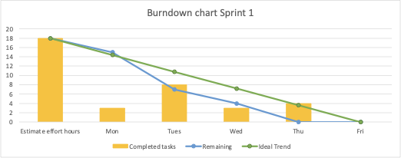

Figure burn down chart for sprint 1

* **Burn down chart for sprint 2**

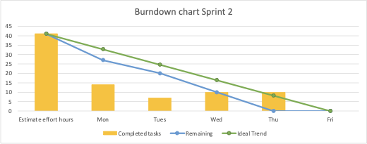

Figure  Burn down chart for sprint 2

* **Burn down chart for sprint 3**

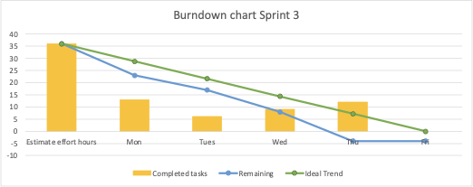

Figure Burn down chart for sprint 2

* **Burn down chart for sprint 4**

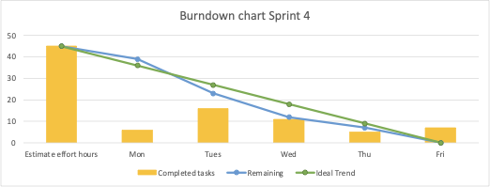

Figure Burn down chart for sprint 4

* **Burn down chart for sprint 5**

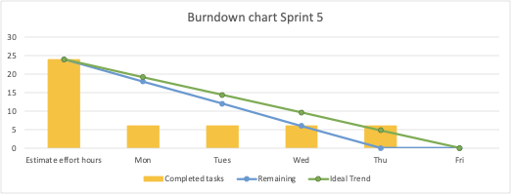

Figure Burn down chart for sprint 5

* **Burn down chart for sprint 6**

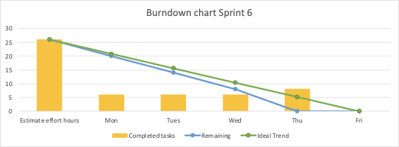

Figure Burn down chart for sprint 6

## Minutes of Meetings

|  |  |  |  |
| --- | --- | --- | --- |
| Meeting Date: | What was discussed? | What was finalised? | Attendance |
| 26/02/2024 | Discussed technologies to use for web app back-end and front-end | Choose Spring Java, MongoDB | H.Phuoc, N.Khoi, P.Loc |
| Create GitHub repository |
| Created a draft version of the project backlog | Finish the draft version of the project backlog |
| 27/02/2024 | Broke down some big functions into small functions to work on | The group finished the product backlog with a priority | H.Phuoc, N.Khoi, P.Loc |
| Decided and prioritised the tasks to focus work on the backlog | Give the plan for all six sprints |
| Gave and assigned tasks to the team members | All team members have tasks assigned |
| 28/02/2024 | Front-end development | Design web front-end for most pages | H.Phuoc, N.Khoi, P.Loc |
| 04/03/2024 | Discuss the Backlog user story and separate the roles | Use-case, Backlog created | H.Phuoc, N.Khoi, P.Loc |
| 05/03/2024 | Discuss about the Technology, GitHub | Choose spring, Mongo. Spring tutorial, and GitHub as source management | H.Phuoc, N.Khoi, P.Loc |
| 06/03/2024 | GitHub working tutorials, database master modify the database | Create ERD and make CRUD function for the web | H.Phuoc, N.Khoi, P.Loc |
| 11/03/2024 | Modify the current required function in the specification | The required functions are modified | H.Phuoc, N.Khoi, P.Loc |
| 12/03/2024 | Discussed the group report and wrote the group report | Assign the work on group reports to team members | H.Phuoc, N.Khoi, P.Loc |
| 13/03/2024 | Analyse and review the required web app functions | Check and complete all required web app functions | H.Phuoc, N.Khoi, P.Loc |
| 18/03/2024 | Decide some additional functions | Additional functions for the web have been decided | H.Phuoc, N.Khoi, P.Loc |
| 19/03/2024 | Group Progress reports for additional functions | Add some additional functions to the report | H.Phuoc, N.Khoi, P.Loc |
| 20/03/2024 | Discuss the final version of the group report and web application functions | Complete all the web app functions needed for the demo | H.Phuoc, N.Khoi, P.Loc |

Table metting table report

## User Stories

As an Admin, I must manage system data, including user accounts and critical academic dates, to ensure that system contents remain up-to-date. Additionally, I require access to statistical reports displaying page views, user activity, and browser usage to gain insights into user interaction.

As a Marketing Manager, I need access to selected contributions to review finalised articles submitted by Marketing Coordinators for their respective faculties. Furthermore, I require the ability to download all selected contributions in ZIP format after the final closure date for easy retrieval and submission for publication. Additionally, I need statistical representations of contributions from each faculty to ensure suitable participation before the closure date. A view-only access to the system allows me to monitor operations and address errors.

As a Marketing Coordinator, I need access to all student contributions within my faculty to review submissions. I also require the ability to provide comments on student contributions within 14 days to facilitate updates before the final deadline.

As a Student, I should be able to upload articles in Word format and high-quality images as part of my contribution. Additionally, I must agree to the University's terms and conditions to contribute.

As a Guest, I want to view selected reports and statistical data for my faculty to learn about students' contributions to the university magazine.

Regardless of role, all users need assurance that their accounts are secure and the ability to monitor account access history for peace of mind.

# Screencast and Presentation

## Presentation:

After several days of working, on the day of our presentation on the website, the presentation was illustrated professionally. While introducing the website, we process it to illustrate the features. With solid preparation, the presentation was smoothly introduced to the end-user. Our evidence of hard work and dedication increased while processing the website and presenting at the exact times. The presentation showed the full features of the website, including additional features that we developed while having more time to implement the website after finishing the requirements features. We also give such a performane in security for the website for example going on with the highest hash method such as Bcryte. Token the ID of the object to prevent any harm from the development top of the browser. There are many fields that we showed, such as:

Security: Loc

Web Core: Phuoc

Charts, Report : Khoi

## Screencast

# Conclusion

Throughout the product development process, the team operated akin to an enterprise software development team, employing agile techniques and tools to ensure the lean delivery of the product. This approach facilitated the creation of an enterprise-ready application that not only fulfils the stakeholders' initial specifications but also surpasses expectations regarding security, robustness, and scalability. In summary, leveraging the factors above, Team Prime has crafted a secure, maintainable, efficient, portable, and scalable magazine management system that comprehensively satisfies all stakeholders' requirements.

# References

AgileNutshell. (2017). *Burndown Charts.* Available: <http://www.agilenutshell.com/burndown> (Last Accessed: 4th April 2017).

Bootstrap. (2016). *About*. Available: <http://getbootstrap.com/about/>. (Last accessed 6th April 2017).

Colourblindawareness. (2017). *Types-of-colour-blindness.* Available: [http://www.colourblindawareness.org/colour-](http://www.colourblindawareness.org/colour-blindness/types-of-colour-blindness/) [blindness/types-of-colour-blindness/](http://www.colourblindawareness.org/colour-blindness/types-of-colour-blindness/)

(Last Accessed 6th April 2017)

Elliot AJ, Maier MA (2014) Color psychology: Effects of perceiving colour on psychological functioning in humans. Annual review of psychology 65: 95–120. doi: 10.1146/annurev-psych-010213-115035. pmid:23808916

Google Inc. (2017). *PageSpeed Insights.* Available: <https://developers.google.com/speed/pagespeed/insights/>. (Last accessed 6th April 2017).

Jakob Nielsen. (1995). *10 Usability Heuristics for User Interface Design.* Available: <https://www.nngroup.com/articles/ten-usability-heuristics/>. (Last accessed 6th April 2017).

Oracle. (2011). *Top 10 Reasons to Choose MySQL for Web-based Applications.* Available: <http://www.oracle.com/us/products/mysql/mysql-wp-top10-webbased-apps-461054.pdf> (Last accessed 24th Mar 2017).

Sutton, C. (2014). *5 Reasons to Use Prezi Rather Than PowerPoint.*

Available: <http://www.business2community.com/tech-gadgets/5-reasons-use-prezi-rather-powerpoint-01050463> (Last accessed 6th April 2017)